PLASMID CONTROL OF SYMBIOTIC PROPERTIES IN
Rhizobium fredii

A THESIS SUBMITTED TO THE GRADUATE DIVISION OF THE
UNIVERSITY OF HAWAII IN PARTIAL FULFILLMENT
OF THE REQUIREMENTS FOR THE DEGREE OF

MASTER OF SCIENCE

IN MICROBIOLOGY
AUGUST, 1986

By

Maria Luz Cases

Thesis Committee
B. Ben Bohlool, Chairman
Leslie R. Berger
Francoise M. Robert

We certify that we have read this thesis and that in our opinion,
it is satisfactory in scope and quality as a thesis for the degree of Master of Science in Microbiology.
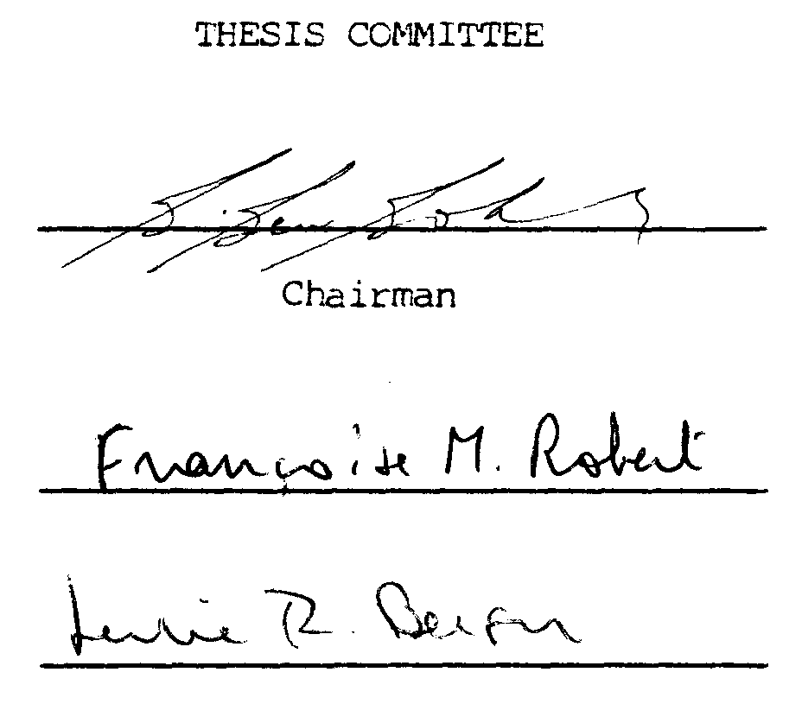

ACKNOWLEDGEMENTS

I would like to express my gratitude to Dr. Ben Bohlool for the opportunity to do research under his tutelage and financial support. I would also like to thank the members of my committee for their constructive suggestions in the preparation of this thesis.
I am indebted to Mark Kingsley for his valuable contributions in all aspects of this research by his technical guidance, helpful comments find friendship. I would also like to acknowledge Dr. Duane Bartholomew of the Department of Agronomy for the use of the growth chambers.
Lastly, I would like to say a very special thank you to my parents and family for their support and encouragement, and to my best friend, Thomas George, for his help, patience, and understanding.
The research was funded in part by grants 58-9AHZ-2-670 from
the U. S. Department of Agriculture and DAN-5542-G-SS-2095-00 from the U. S. Agency for International Development.

ABSTRACT

Large indigenous plasmids are a common feature in members of the genus Rhizobium, and their involvement in the control of symbiotic functions has been established. Studies on these rhizobial plasmids, called pSym plasmids, make up much of what is understood about the molecular and genetic basis of the N₂-fixing symbiosis. The soybeans, generally nodulated by slow-growing rhizobia, are an economically important crop but genetic studies about this group of rhizobia have made little progress because of their slow growth rate and the absence of identifiable plasmid-associated symbiotic functions. An approach to understanding the symbiosis in the soybean system is to use as a genetic model, R. fredii, the fast-growing rhizobia that nodulate soybeans.
In this study, five strains of R. fredii were examined for the presence of indigenous plasmids. To determine if symbiotic functions are controlled by genes on these plasmids, the strains were subjected to plasmid-curing treatments. The effect of a pSym plasmid from a heterologous species on R. fredii gene function was studied by the introduction of the R. leguminosarum pSym plasmid, pJB5JI.
The results of this study show that high molecular weight plasmids that are involved in determining symbiotic functions, as well as cryptic plasmids, are an integral part of the genetic make-up of R. fredii. These strains can receive and maintain p7B5JI, a pSym plasmid from another Rhizobium species. However, the pJB5JI plasmid genes are not expressed in the R. fredii genetic background. The introduction of the plasmid did not enable any of the R. fredii transconjugants to nodulate peas, nor did it restore the ability of the plasmid-cured transconjugants to nodulate soybeans. The presence of the plasmid affected the expression of the R. fredii symbiotic genes, resulting in different levels of symbiotic effectiveness.

TABLE OF CONTENTS

ACKNOWLEDGEMENTS .................................... 3
ABSTRACT ............................................ 4
LIST OF TABLES ...................................... 7
LIST OF FIGURES ..................................... 8
CHAPTER 1. INTRODUCTION ............................ 9
CHAPTER 2. MATERIALS AND METHODS ................... 22
Bacterial Strains ....................... 22 Maintenance of Cultures ................. 22 Assessment of Culture Purity and
identification of strains ............... 22
Plasmid Profile Analysis ................ 25
Development of Mutants .................. 26
Bacterial Matings ....................... 28
Plant Infection Tests ................... 29
CHAPTER 3. RESULTS ................................. 32
Plasmid Profiles ........................ 32
Isolation of Plasmid-Cured Mutants ...... 38
Transfer, Expression and Maintenance
of pSym Plasmid ......................... 41
CHAPTER 4. DISCUSSION .............................. 58
LITERATURE CITED..................................... 66

LIST OF TABLES

Table Page

1 Characteristics and sources of
Rhizobium strains used in the study ........... 23

2 Acid production and FA reactions of
R. fredii and R. leguminosarum strains ........ 33

3 Intrinsic antibiotic resistance patterns
of R. fredii and R. leguminosarum strains ..... 34

4 Phage-typing patterns of R. fredii and
R. leguminosarum strains ...................... 35

5 Symbiotic properties of parent and plasmid-
cured R. fredii strains on soybeans ........... 42

6 Frequency of natural kanamycin resistance
in R. fredii strains .......................... 44

7 Frequency of transfer of kanamycin resistance
marker in crosses between R. leguminosarum 6015
(pJB5JI) and R. fredii ........................ 45

8 Presence or absence of the plasmid pJB5JI
and symbiotic properties of R. fredii
transconjugants................................ 46

9 Frequency of transfer of kanamycin resistance
marker in backcrosses between R. fredii
transconjugants and R. leguminosarum 6015 ..... 50

10 Summary of the pJB5JI donor, plasmid
content, and symbiotic properties of
R. leguminosarum 6015 transconjugants ......... 54

11 Nodulation and nitrogen fixation by
isolates of R. fredii transconjugants after
first passage on Peking soybeans .............. 55

12 Nodulation and nitrogen fixation by
isolates of R. fredii transconjugants after
second passage on Peking soybeans ............. 57

LIST OF FIGURES

Figure Page

1 Agarose gel electrophoresis of plasmid
DNA from R. fredii ............................ 37

2 Plasmid profiles of R. fredii cured
mutants and parent strains .................... 40

3 Plasmid profiles of USDA 205-A05
transconjugants and reference strains ......... 49

4 Plasmid profiles of R. leguminosarum
6015 and its transconjugants .................. 52

CHAPTER 1
INTRODUCTION

The rhizobia are Gram-negative soil bacteria belonging to the genus Rhizobium which fix nitrogen in a symbiotic association with legumes. Establishment of the N₂-fixing symbiosis starts with the colonization, recognition and invasion of the plant root by free-living rhizobia in the soil, followed by a series of steps that result in the formation of a nodule. It is in these nodules that the rhizobia differentiate into bacteroids and reduce atmospheric nitrogen to ammonia with the enzyme nitrogenase.
In the symbiosis, both the plant host and the bacterial endosym-biont play particular roles that are regulated by gene expression. The frequency with which certain symbiotic properties such as infectiveness and effectiveness were lost, and the stimulation of this loss by treatments known to affect plasmids has led to the suggestion that symbiotic properties are plasmid-borne.

Indigenous plasmids in rhizobia

The presence of plasmids with molecular weights higher than 100 megadaltons (Mdal) is a general feature in the family Rhizobiaceae. This has been correlated with some biological effects of the bacterial symbiont on the plant, including the induction of crown gall by Agrobacterium and the establishment of N₂-fixing symbioses by Rhizobium and Bradyrhizobium. In rhizobia, the plasmids have also been found to bear genes for the production of the melanin pigment (Beynon, et al., 1980), bacteriocins (Hirsch, 1979), cell wall polysaccharides (Prakash, 1980) and uptake hydrogenase (Brewin et al., 1980c). However, the function of most of the DNA in these plasmids remains unknown.
Strains of both the fast-growing Rhizobium and the slow-growing Bradyrhizobium typically harbor one to several plasmids. A great percentage of their DNA is in the form of large, low copy number (1-3 per cell) plasmids, representing at least 5 to 20 per cent of the total genomic information (Beringer et al., 1980).
In terms of physical evidence, many indigenous plasmids were isolated by alkaline denaturation-phenol extraction and visualized by gel electrophoresis (Casse et al., 1979; Hirsch et al., 1980; Nuti et al., 1977; Prakash et al., 1980). The larger megaplasmids were detected by the more sensitive Eckhardt direct-lysis method of gel electrophoresis (Denarie et al., 1981; Eckhardt, 1978; Rosenberg et al., 1982;).
Large plasmids were found in Rhizobium leguminosarum, Rhizobium trifolii, Rhizobium phaseoli, and Rhizobium meliloti (Beynon et al., 1980b; Casse et al., 1979; Denarie et al., 1981; Hirsch et al., 1980; Nuti et al., 1977; Prakash, 1980). In R. meliloti, different isolation procedures revealed two classes of plasmids. One class consisted of medium range 90- to 200-Mdal plasmids (Casse et al., 1979) and a second class consisted of plasmids with sizes greater than 300 Mdal, referred to as megaplasmids (Banfalvi et al., 1981; Denarie et al., 1981; Rosenberg et al., 1981). By means of electron microscopy, Burkhardt and Burkhardt (1984) estimated their size to be 1000 Mdal.
In the case of slow-growing rhizobia, Gross et al. (1979) examined Bradyrhizobium japonicum isolated from alkaline soils and observed large plasmids. Other strains from various geographical origins ware examined by Masterson et al. (1982) and all of those examined contained at least one large plasmid, with sizes ranging from 118 to 1915 Mdal. They concluded that the presence of plasmids is a consistent feature of most B. japonicum strains.
Evidence has been presented that in the endosymbiotic bacteroids, the large plasmids are extensively transcribed. Krol et al. (1980) studied R. leguminosarum and found that in contrast to the bacteroids, there was no detectable transcription of the plasmid in broth cultures, showing that under these conditions, plasmid genes are not expressed. They suggested that the large rhizobium plasmids contain not only the genes that control N₂-fixation but also the genes which are functional during the differentiation of bacteria into bacteroids.

Plasmid involvement in symbiotic nitrogen fixation

Physical and genetic studies have now established that, at least in fast-growing Rhizobium species, the majority of the genes that control symbiotic functions such as host-range specificity, nodulation, and N₂-fixation are usually on a plasmid referred to as the pSym plasmid.
In several fast-growing Rhizobium species, genes controlling symbiotic functions have been localized on large plasmids ranging in size from 130 Mdal in R. leguminosarum (Hirsch et al., 1980) to more than 450 Mda1 in R. meliloti (Denarie et al., 1981). In slow-growing rhizobia such as B. japonicum, plasmids controlling symbiotic functions have not been identified and the symbiotic genes are presumed to be located on the chromosome.

Host range specificity

Host selectivity at the early stages of infection is a striking feature of the rhizobia-plant interaction. With one known exception (Parasponia), the rhizobial plant hosts are members of the family Leguminosae, and within this family, groups of plants are nodulated by particular Rhizobium species. There is evidence that the pSym plasmid carries genes determining host-range specificity (hsn).
Brewin et al. (1981) reviewed the role of Rhizobium plasmids in host specificity, and concluded that, at least for the three closely related species, R. leguminosarum, R. trifolii, and R. phaseoli, host-range is a plasmid-determined trait.
Plasmid-controlled host specificity in R. leguminosarum was first described by Johnston et al. (1978). In the study, a R. leguminosarum plasmid, pJB5JI, was transferred to R. trifolii and R. phaseoli. All transconjugants were capable of forming nodules on peas in addition to their normal hosts. By cloning the nodulation genes of the plasmid, Downie et al. (1983) showed that host specificity is determined by a DNA sequence of no more than 10 kilobases (kb).
In R. trifolii, mutagenesis of host-specific nodulation genes in the pSym plasmid by the transposon Tn5, a short segment of DNA coding for the antibiotic kanamycin and which is capable of inserting within a genome, resulted in mutants with altered host-range ability. The mutants showed either poor nodulation on clover or none at all (Djordjevic et al., 1985). A 14-kb fragment of the pSym plasmid was mobilized and conferred clover-specific nodulation on another strain of R. trifolii that was cured of the pSym plasmid, as well as on Agrobacterium tumefaciens, a member of another genus in Rhizobiaceae (Schofield et al., 1984).
Particular host-range characteristics within a cross inoculation group were also found to be plasmid-controlled. The strain R. leguminosarum TOM, which nodulates the primitive pea cultivar Afghanistan, was able to transfer this trait at low frequencies to a strain that does not normally nodulate this cultivar. The transfer of cultivar specificity was associated with the transfer of a 160-Mdal plasmid designated pRL5JI (Brewin et al., 1980).
Other reports gave evidence for the presence of host-range determinants on pSym plasmids (Appelbaum et al., 1985; Beynon et al., 1980; Djordjevic et al., 1983; Hooykaas et al., 1981; Kondorosi et
al., 1982; Morrison et al., 1983).

Nodulation

Successful interaction of a rhizobia with their plant host results in the development of an organized structure, the root nodule. The early stages of nodule formation include root hair colonization and adhesion, root hair curling, infection thread development, cortical cell multiplication, release of rhizobia in the host cells, and proliferation of bacteria within the plant cells. The later stages encompass events such as bacteroid differentiation, host cell enlargement, and the start of nitrogen fixation (Verma and Long, 1983).
The role of plasmids in the control of nodule formation has been demonstrated by studies on plasmid-cured mutants, transposon mutagenesis, and plasmid transfer experiments.
The association of plasmid loss and a non-nodulatiog (Nod⁻) phenotype provided early evidence of plasmid involvement in nodulation. Higashi (1967) found that the ability of R. trifolii to nodulate clover was lost at high frequency following treatment with acridine orange, a chemical agent known to cause the elimination of plasmids (Clowes et al., 1965; Parijkaya, 1973).
Zurkowski and Lorkiewicz (1976, 1978) correlated plasmids in R. trifolii with nodulation, by showing that Nod⁻ mutants resulting from a prolonged treatment at high temperature were due to either loss of plasmid DNA or internal deletions in the plasmid. Zurkowski (1982) reported that at high temperature, DNA synthesis stops while protein synthesis continues, leading to the formation of enlarged cells, and the loss of the plasmid during cell division. The transfer of the plasmid into the Nod⁻ strains which had lost the ability to attach to the root hair surface, converted them to a Nod⁺ phenotype (Zurkowski, 1981). The absence of the symbiotic function that was associated with plasmid loss and its restoration with plasmid transfer, point to the involvement of the plasmid in the nodulation process.
Similarly, prolonged heat treatment of R. leguminosarum resulted in Nod⁻ strains that exhibited modified surface properties (Prakash et al., 1980). The mutants lost the ability to agglutinate in the presence of pea lectin, a plant protein that recognizes and binds with specific carbohydrate components of the bacterial cell surface. Lectin binding is a function that has been correlated with host specificity (Bohlool and Schmidt, 1974; Dazzo and Hubbel, 1975).
In R. meliloti, the early functions in the infection process are reported to be on a megaplasmid (Rosenberg et al., 1981). Previously, Palomares et al. (1978) had shown that in R. meliloti, extrachromosomal DNA was responsible for polygalacturonase, a key enzyme originally thought to be involved in the early infection process (Ljunggren and Fahraeus, 1961). Long et al. (1982) cloned the nod genes which complement the nodulation defect of a Nod⁻ R. meliloti mutant and assigned the nodulation function to a region of the 8.7-kb EcoRI fragment on the megaplasmid.
Although the nodulation process is characterized by a high degree of specificity, some of the genes involved in the early steps of nodulation were found to be conserved and common across different rhizobia. A proposed genetic model is that there is a core of nodulation-specific genes that are essentially the same in different Rhizobium species and that host range is determined by ancillary host range genes (Downie et al., 1983).
Kondorosi et al. (1984) identified DNA regions of a R. meliloti megaplasmid carrying nod genes involved in root hair curling, an early step in nodule formation. The genes, referred to as the common nod genes, are active in a wide range of plant hosts and mutations in these can be complemented by pSym plasmids from other Rhizobium species such as R. leguminosarum. The genes nodABCD, which are clustered in the pSym plasmid have been identified in several species of Rhizobium (Banfalvi et al., 1981; Djordjevic et al., 1985; Fischer et al., 1985).
The functional conservation of nod genes in the fast-growing strains may also extend to the slow growers. When DNA fragments from Bradyrhizobium sp. (Parasponia) were introduced into a Nod⁻ R. meliloti strain, nodulation ability was restored (Marvel et al., 1984). Noti et al. (1985), using a DNA region from Bradyrhizobium sp. (Vigna), reported similar findings.

Nitrogen fixation

Johnston et al. (1978) demonstrated that the transfer of a R. leguminosarum plasmid into a Fix⁻ strain restored its normal symbiotic function, implying that the genes that control the ability to fix nitrogen are located on plasmids. Furthermore, the transfer of the R. leguminosarum bacteriocinogenic plasmid pRLlJI into symbiotic mutants, including nodulation-deficient ones restored them to Fix⁺ phenotypes (Brewin et al., 1980a). The location of the genes involved in N₂-fixation was confirmed by hybridization with a recombinant DNA clone carrying the nitrogenase (nif) genes from Klebsiella pneumoniae. The K. pneumoniae nifD and nifH genes, which encode two of the three nitrogenase subunit polypeptides, hybridizes to DNA restriction fragments of many diverse N₂-fixing bacteria, indicating the conservation of the nif genes at the DNA sequence level (Ruvkun and Ausubel, 1980a). Hybridization experiments have established the presence of nif genes in R. leguminosarum (Nuti et al., 1979), R. phaseoli (Hombrecher et al., 1981), R. trifolii (Hooykaas et al., 1981; Schofield et al., 1985), R. meliloti (Banfalvi et al., 1981; Rosenberg et al., 1981), and a fast-growing cowpea Rhizobium (Morrison et al., 1983). Homology studies between the pSym plasmids of diverse fast-growing Rhizobium species showed that a specific DNA sequence which carries the structural genes for nitrogenase is highly conserved in R. leguminosarum, R. trifolii, and R. phaseoli (Prakash et al., 1981).
Slow-growing rhizobia, including B. japonicum have not been shown to carry nif sequences on plasmid DNA (Masterson et al., 1982).

Linkage of genes

The genes for nodulation and N₂-fixation as well as for other functions are linked on a plasmid in most Rhizobium strains. In many cases, the pSym plasmid found to bear nif sequences was also known to encode for nodulation and host-range specificity, and for other functions.
Tn5 insertions in a R. leguminosarum plasmid (Buchanan-Wollaston et al., 1980) and in a R. meliloti megaplasmid (Meade et al., 1982) could produce both Nod⁻ and Fix⁻ phenotypes. In studies of the R. meliloti megaplasmid, it was shown that in a large number of spontaneous Nod⁻ mutants, a deletion of the megaplasmid occurred with the concommitant loss of the sequence homologous to nif. By analyzing such deletions, Banfalvi et al. (1981) and Rosenberg et al. (1981) deduced close linkage of the nod and nif loci. Physical and genetic data have confirmed that the nod genes are located within 30 kb of the nif genes on the megaplasmid (Long et al., 1982).
Hybridization experiments showed that nodulation and nitrogen fixation genes are found in the same plasmid in R. leguminosarum (Hombrecher et al., 1981), R. phaseoli (Lamb et al., 1982), R. trifolii (Hooykaas et al., 1981) and a fast-growing cowpea Rhizobium (Morrison et al., 1983). The molecular linkage map of the nitrogenase and nodulation genes was constructed in R. trifolii by Schofield et al. (1983). Hooykaas et al. (1981) reported that the R. trifolii pSym plasmid not only determines host specificity for clover, but also controls other steps in nodulation and N₂-fixation.
In crosses between R. leguminosarum and R. trifolii, host-range specificity is cotransferred with other nodulation loci (Djordjevic et al., 1983; Downie et al., 1983; Hombrecher et al., 1984; Schofield et al., 1984).
Close linkage with the symbiotic genes on the pSym plasmids is shown by genes that control other functions. Beynon et al., (1980b) observed that spontaneous plasmid deletions eliminated both melanin producticn and the ability to nodulate Phaseolus beans and suggested that the genes involved in the control of both functions are on a single plasmid. Brewin et al. (1980c) identified a R. leguminosarum plasmid which not only carried nif and nod genes but also specified the genes controlling the production of uptake hydrogenase, an enzyme that catalyzes the oxidation of the hydrogen liberated during nitrogen reduction.

Expression of the pSym plasmid in different species

The transfer of indigenous Rhizobium plasmids has been reported earlier by Cole and Elkan (1973), Higashi (1967), Hirsch (1979), and Johnston et al. (1978). The pSym plasmids in some strains of R. trifolii, R. leguminosarum, and R. phaseoli are self-transmissible, but the pSym megaplasmids of R. meliloti are not. They have been transferred to other strains by recombination with a transmissible plasmid (Brewin et al., 1980a), by cointegration with RP4 (Kowalczuk et al., 1981; Scott and Ronson, 1982), and by introduction of a mobilization site (Simon, 1983).
The transfer of plasmids coding for symbiotic functions to different species often results in variable expression. Hooykaas et al. (1981) observed that the pSym plasmids of R. leguminosarum and R. trifolii expressed symbiotic properties fully when transferred between these two strains. However, when transferred to R. meliloti, the transconjugants formed nodules on the host plants but did not fix nitrogen. The same results were shown when these pSym plasmids were transferred to Agrobacterium tumefaciens. An examination of the nodules by electron microscopy showed the presence of numerous infection threads and a peribacteroid membrane but not the presence of bacteroids. When the nif and nod genes from the pSym megaplasmid of R. meliloti were mobilized by RP4 and transferred to A. tumefaciens, the transconjugants induced root deformations which cytologically resembled real nodules in alfalfa (Truchet, 1984).
The transfer of the R. leguminosarum plasmid pJB5JI to a Nod⁻
R. trifolii strain resulted in transconjugants that formed effective nodules on peas but no nodules on clover. However, the transconjugant reisolates from the pea nodules were able to nodulate clover (Sadowsky,, 1983; Sadowsky and Bohlool, 1985).
Djordjevic et al. (1983) found that the transfer of the plasmid pBRIAN which encodes clover specificity, to plasmid-cured R. meliloti strains did not result in the ability of R. meliloti to nodulate clover.
According to Djordjevic et al. (1982) and Christensen and Schubert (1983), incompatibility and instability of the pSym plasmids may be factors that contribute to the variable expression of symbiotic genes in different hosts.

Objectives of present study

Considerable progress has been made in understanding the rhizobial genes involved in symbiotic N₂-fixation with the fast-growing strains. Genetic studies of the symbiotic relationship between legumes and rhizobia have relied largely on R. leguminosarum, R. trifolii, R. phaseoli, and R. meliloti. This is mainly due to their fast growth rate, ease of handling and lysis as well as their suitability for recombinant DNA techniques.
Progress has been hindered in the genetic analysis of the slow-growing strains due to the absence of identifiable plasmid-associated symbiotic genes. Although the organization of structural genes for nitrogenase is understood in the slow-growing B. japonicum, little is known about the other genes involved in symbiotic nitrogen fixation. At present, there are no reliable methods of gene transfer systems in the slow-growing species. Kuykendall (1979) and Pilacinski and Schmidt (1981) have been successful in introducing Pl group plasmids (R68.45 and RP4 originally from Pseudomonas and E. coli) into B. japonicum and other cowpea rhizobia but with a very low frequency. The genetic analysis of the slow-growing rhizobia is further complicated by the observed instability of their genome, as evidenced by the spontaneous indigenous rearrangements between the chromosome and plasmid DNA (Berry and Atherly, 1984).
The dearth of knowledge in this area is unfortunate because these rhizobia nodulate agronomically important legumes. They are also bio-chemically well characterized and can routinely be shown to reduce significant amounts of acetylene as free-living bacteria (Keister, 1975).
The fast-growing strains of soybean-nodulating rhizobia isolated from the People's Republic of China (Keyser et al.,(1982) present an alternative model for studying the genetic control of the N₂-fixing symbiosis in the soybean system. These strains represent a class of rhizobia intermediate between classical fast- and slow-growing types. They resemble the fast-growing species physiologically and nodulate Glycine soja, the ancestral soybean, and Glycine max. However, they generally form ineffective nodules on the commercial soybean cultivars.
Members of the group, classified as Rhizobium fredii (Scholla and Elkan, 1984), harbor high-molecular weight plasmids. The strains examined contain 1-3 plasmids with sizes up to 200 Mdal (Masterson et al., 1982; Sadowsky and Bohlool, 1985) and most were also found to contain plasmids that are larger than 450 Mdal (Appelbaum et al., 1984; Broughton et al., 1984; Heron and Pueppke, 1984).
Both nodulation and nitrogenase genes have been shown to be carried on the 150-200 Mdal plasmids, with some exceptions which may carry the symbiotic genes on the chromosome (Broughton et al., 1984; Masterson et al., 1982). A single plasmid of about 200 Mdal has homology to a cloned DNA fragment containing the nifD and nifH genes of R. meliloti in most of the strains examined (Masterson et al., 1982). In two strains, plasmid DNA hybridizes to both R. meliloti nif and nod sequences (Prakash and Atherly, 1984). Loss of a 200-Mdal plasmid from one strain results in loss of the ability to nodulate soybeans (Sadowky and Bohlool, 1983). Mobilization of a 200-Mdal plasmid from USDA 191 to other Rhizobium strains that neither nodulate soybeans nor form effective nodules on certain cultivars enabled the transconjugants to form nodules or nodule-like structures on soybeans (Appelbaum et al., 1985). The symbiotic properties of the transconjugants indicate that both soybean specificity for nodulation and cultivar specificity for nitrogen fixation are plasmid-encoded in R. fredii (Appelbaum et al., 1985).
Sadowsky and Bohlool (1985) used these soybean rhizobia and R. trifolii strains as recipients of the R. leguminosarum plasmid pJB5JI, and reported the differential expression of the plasmid in the different genetic backgrounds.
Masterson et al. (1985) demonstrated the conservation of DNA sequences of the symbiotic genes within and between B. japonicum and R. fredii strains. The structural organization of the symbiotic genes appears highly conserved in the R. fredii and B. japonicum strains examined regardless of the plasmid or chromosomal location of the genes.
A second group of R. fredii strains that was isolated (Dawdle, 1985) is especially attractive for genetic studies because the strains form effective nodules on the commercial soybean cultivar Williams as well as Peking. This group is similar to USDA 191, the only strain from the first set of R. fredii (Keyser et al., 1982) known to form Fix⁺ nodules on commercial cultivars (Hattori and Johnson, 1984). It was also shown that these strains were highly competitive on two soybean cultivars (Williams and Ai Jiao Zao) in the soil where they naturally occurred, and under certain conditions, are effective as inoculum strains (Dawdle, 1985).
By using the soybean system as a model, the purpose of this research is to understand the genetic control of the Rhizobium-legume symbiosis. With this broad aim, the following objectives were formulated:
1. To examine the fast-growing R. fredii strains for the presence of large indigenous plasmids;
2. To determine whether symbiotic genes are carried on these plasmids; and,
3. To study the transfer, expression and maintenance of pSYM plasmids from another species.

CHAPTER 2
MATERIALS AND METHODS

Bacterial strains

The Rhizobium strains used in this study, their relevant characteristics, and sources are listed in Table 1.

Maintenance of cultures

The cultures were maintained on yeast extract-mannitol medium (YEM) agar (Bohlool and Schmidt, 1970) slants containing 0.05% CaCO₃. Antibiotic resistant mutants and transconjugants were maintained on tryptone-yeast extract medium (TY) agar (Beringer, 1974) slants or plates with the appropriate antibiotics (Sigma Chemical Co., St. Louis, Mo.). Chloramphenicol was used at 20 ug ml⁻¹, kanamycin at 50 ug ml⁻¹, streptomycin at 200 ug ml⁻¹, and rifampicin at 20 ug ml^{-l}.

Assessment of culture purity and identification of strains

The purity of the cultures was assessed by streaking on YEM agar plates with 0.25 mg 1⁻¹ brom thymol blue. The plates were examined for colony morphology and acid production.
The identity of the strains was determined by immunofluorescence (Schmidt et al., 1968), by intrinsic antibiotic resistance patterns (Josey et al., 1979; Kingsley and Bohlool, 1983), and by phage typing (Adams, 1959; Dowdle, 1985). The plasmid profile of each strain was also used to differentate one strain from another. A combination of these methods was used to check the identity of the isolates from mutation and mating experiments and the reisolates from plant tests.

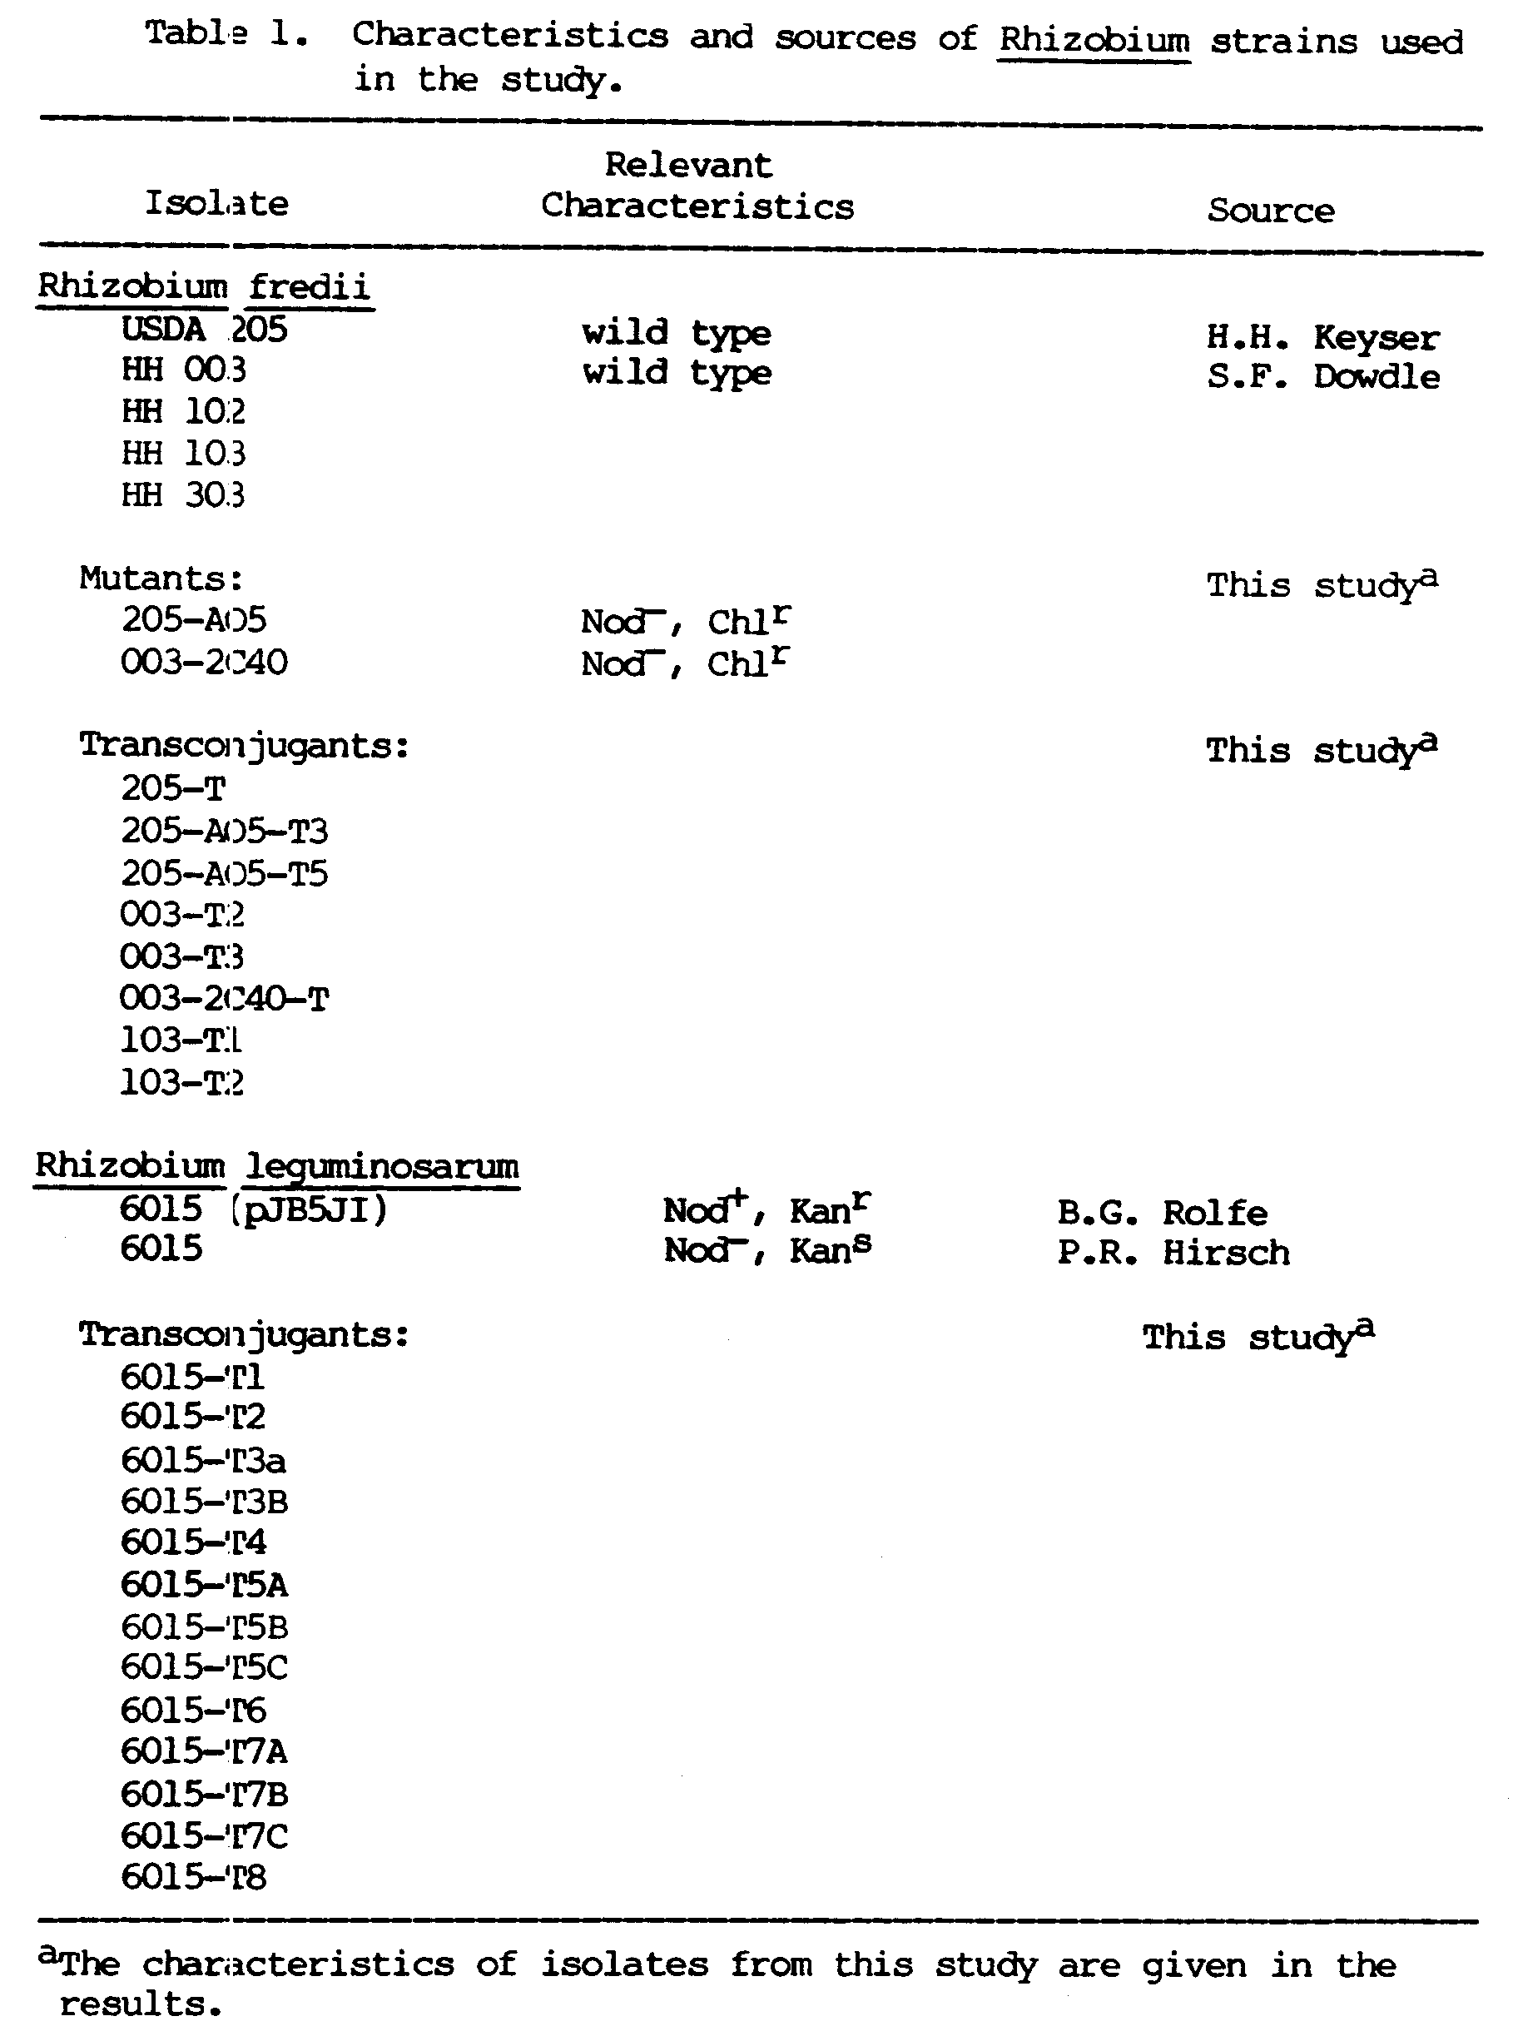
Immunofluorescence
Fluorescent antibodies (FAs) specific for R. fredii USDA 205 and HH 003 and R. leguminosarum 6015 (prepared by M. Sadowsky and B.B. Bohlool) were used to identify these strains. Smears were made from broth cultures or macerated nodule suspensions, which in the case of R. fredii, were boiled in a water bath for 30 min to enhance the reaction of the FA. Gelatine-rhodamine isothiocyanate was used to suppress nonspecific adsorption (Bohlool and Schmidt, 1968). The smears were stained with the FAs, and incubated in a moist chamber for 30 min. The excess stain was washed off with phosphate buffered saline (PBS), pH 7.2, and the slides soaked in PBS for 20 min. The slides were rinsed twice with distilled water, air dried, and observed with a Zeiss standard microscope equipped for epifluorescence microscopy with a fluorescein isothiocyanate filter, and a Zeiss condenser with phase objectives. Cross-reactios of FA-stained smears were quantitated by assessment of the degree of fluorescence from 0 to 4+.

Intrinsic antibiotic resistance
Filter-sterilized solutions of antibiotics were added to melted YEM agar which had been cooled to 50ºC, to give the following final concentrations (ug ml⁻¹): chloramphenicol (Chl) 12.0, 25.0; kanamycin sulfate (Kan) 10.0; nalidixic acid (Nal) 10.0; neomycin sulfate (Neo) 2.5; polymixin B sulfate (Pol) 20.0; rifampicin (Rif) 1.0, 6.0; streptomycin (Str) 2.5, 10.0; tetracycline hydrochloride (Tet) 1.0; and vancomycin hydrochloride (Van) 1.5, 5.0. The antibiotic stock solutions were prepared at a concentration of 10 mg ml⁻¹ in distilled water except Chl (10 mg ml⁻¹ in 95% ethanol), Nal (10 mci ml⁻¹ in 1N NaOH), and Rif (10 mg ml⁻¹ in methanol). YEM agar plates without antibiotics served as controls.
To inoculate several strains on the surface of agar plates simultaneously, 200-ul volumes of 24-hour old YEM broth cultures were transferred to the wells of a sterile Falcon 96-well tissue culture plate and then inoculated onto the plates with a sterile multiple inoculator. Duplicate plates were incubated at 28ºC for seven days and isolates showing growth were scored as positive for antibiotic resistance.

Phage typing
Assays on phage susceptibility were cone on R. fredii HH strains using the standard agar overlay method (Adams, 1959; Dowdle, 1985). Vincent's defined agar medium (Vincent, 1970) with 1.0% agar was used as the basal layer, and the same medium with 0.42% agar was used as the top layer. Cells were grown on YEM broth to mid-exponential phase and 200 ul of the culture was added to the molten top agar, spread onto the basal agar layer, and allowed to solidify. The wells of a sterile tissue culture plate were filled with 200 ul each of phage stock solutions (isolated by S. Dowdle from soybean-growing regions of China with indigenous populations of R. fredii), and a flame-sterilized multiple inoculator was used to transfer the phages to the plate. Phages were not transferred to the control plates. Duplicate plates were incubated at 28ºC and observed for lysis after 48 h.

Plasmid profile analysis

A direct lysis procedure was used to isolate plasmid DNA. Plasmid profiles of parent strains and transconjugants were obtained using a modification of the Eckhardt (1978) in-well lysis and agarose gel electrophoresis technique described by Rosenberg, et al. (1982) and M. Kingsley (personal communication).
Cells were grown overnight in TY, YEM, or peptone (PA) (Hirsch, et al., 1980). Depending on the strain, 200- to 300-ul volumes of the broth cultures were centrifuged in 1.5 ml plastic Eppendorf tubes to harvest the cells. As a preliminary step, the cells were washed with a dilute detergent solution of TEN buffer (0.05M Tris-base, 0.02M EDTA, 0.02M NaCl) containing 0.1% Sarkosyl (Schwinghamer, 1980). The pellet was loosened by vigorous blending in a Vortex mixer, and 40 ul of sphereoplasting solution was added. This solution contained 7,500 ug ml^{-l} lysozyme (Sigma), 30 U ml⁻¹ RNAse I (Worthington Diagnostics, Freehold, N.J.), 20% Ficoll 400 (Sigma), 0.05% bromo-phenol blue in TEB buffer (89mM Tris-base, 8.9mM EDTA, 89mM boric acid). The cell suspension was then layered beneath 200 ul TEB in a well of a 3-mm thick vertical gel. The 0.7% agarose (low m_{r}; Bio-Rad Laboratories, Richmond, Calif.) gel was prepared by melting the agarose in TEB in the microwave oven, and readjusting for evaporation loss by adding distilled water.
After: a 15-minute incubation to allow for lysozyme action, the lysis procedure was completed by adding an overlay of 0.2% sodium dodecyl sulfate (SDS) solution in TEB with 10% Ficoll 400. This was followed by a second overlay solution of 0.2% SDS solution in TEB with 5% Ficoll 400. The wells were sealed with molten agarose, and electrophoresis was done at 8 mA for 2 h. The current was then increased to 40 mA and electrophoresis was continued for 5 h. After staining with ethidium bromide (5 ug ml⁻¹), the plasmid DNA was visualize) with a UV transilluminator, then photographed using Polaroid 107C film and UV and yellow (Hoya, K2) filters.
The approximate molecular weights of the plasmids were determined from their relative mobilities in agarose gels by using the 130-Mdal pJB5JI and plasmids of R. leguminosarun (Hirsch et al., 1980), R. trifolii T-12 (Rosenberg et al.,1982), and R. meliloti L5-30 (Rosenberg et al., 1982) as molecular weight markers.

Development of mutants

Plasmid-cured mutants
Plasmid curing was done by acridine orange treatment, by heat treatment, or by a combination of both.
The acridine orange treatment was done according to the procedure of Zurkowski et al. (1973). Overnight YEM broth cultures were used to inoculate fresh broth containing 1, 3, 5, 10, 15, and 20 ug ml⁻¹ acridine orange (Sigma). The cultures were incubated in the dark at 25ºC on a shaker for six days. After incubation, the cultures were diluted in 0.09% (w/v) NaCl and plated on minimal medium (MM) agar (Vincent, 1970) to exclude auxotrophs. The resulting colonies were transferred to MM broth to eliminate the possibility of cross-feeding, then streaked once more on MM plates. Single colonies were picked and their DNA was observed on agarose gels for changes in their plasmid profiles.
The procedure of Zurkowski and Lorkiewicz (1978) was used for heat curing. Overnight YEM broth cultures were inoculated into PA broth. The cultures were incubated in 35, 37, 40, and 45ºC water baths, and given daily 5-second blending in a Vortex mixer for aeration. The cultures were transferred to fresh broth at weekly intervals. After heat treatment, the cultures were plated on YEM agar and the plasmid profiles of single colony isolates were observed.
In cases where plasmid curing was difficult, the strains were given a combination of acridine orange and elevated temperature simultaneously.

Antibiotic resistant mutants
Spontaneous antibiotic resistant mutants were obtained by growing the cells initially in 50 ml of YEM broth containing 10 ug ml⁻¹ Chl. To boost the level of resistance, the cells were harvested by centrifugation and transferred to fresh broth with increasing antibiotic concentrations. The cultures growing in broth containing 20 ug ml⁻¹ Chl were then streaked on TY plates with the same antibiotic concentrations.

Bacterial matings

The procedure for bacterial conjugation was that described by Buchanan-Wollaston et al. (1980). Crosses were done by suspending 1 ml of cultures grown overnight that contained approximately 10⁸ cells in sterile saline. The recipient and the donor cells were filtered successively onto a 0.45-um pore size Millipore filter (Millipore Corp., Bedford, Mass.). The filters were incubated on TY plates at 28ºC overnight. The cells were collected from the filter by placing it in an empty sterile Petri dish, adding 5 ml of sterile saline, and suspending the cells with the aid of a sterile stir bar. The cell suspensions were serially diluted and plated on selective and nonselective media.
To select for R. fredii transconjugants which received the pJB5JI kanamycin marker, and to counterselect against the donor R. leguminosarum 6015 (pJB5JI), TY medium, supplemented with 50 ug ml⁻¹ Kan and 20 ug ml⁻¹ Chl, was used. In backcrosses to the Nod⁻ mutant R. leguminosarum 6015, TY medium, supplemented with 50 ug ml^{-l} Kan, 20 ug ml⁻¹ Rif, and 200 ug ml⁻¹ Str, was used for selection.
The same procedure was used on the donor and recipient cultures separately to serve as controls. The transfer frequency of each cross was calculated as the number of transconjugants per total number of recipients. Viable cell counts were made from selective plates using the Miles and Misra drop-plate count method (Vincent, 1970). R. leguminosarum 6015 (pJB5JI) was counted from a TY plate containing 50 ug ml⁻¹ Kan while R. fredii was counted from a TY plate containing 20 ug ml⁻¹ Chl. Viable cells counts were also made from nonselective TY plates.

Plant infection tests

Plant culture
Nodulation tests for soybeans and peas were done in modified Leonard jar assemblies (Leonard, 1943). The growth assembly was that used by Sadowsky (1983) and consisted of a 250-ml wide mouth Erlenmeyer flask which served as the growth vessel and a 500-ml wide mouth screw-cap bottle which served as the nutrient reservoir. The two components were glued together and an absorbent cotton wick between the two facilitated the transfer of nutrient solution from the lower nutrient reservoir into the plant growth vessel above. The nutrient reservoir was filled with quarter strength nitrogen-free medium by Hoagland and Arron (1938). The growth vessel was filled with a 3:1 (v/v) mixture of washed vermiculite and perlite and then moistened with the nutrient solution. The growth assembly was covered with aluminum foil and autoclaved for 45 min (121ºC, 15 psi).
Pea, (Pisum sativum cv. Wisconsin Perfection) and soybean (Glycine max cv. Peking and Williams) seeds were surface-sterilized by immersion in a 4.0% (w/v) calcium hypochlorite solution for 20 min, followed by five washings with sterile distilled water. The seeds were allowed to imbibe for four h, and then three seeds were transferred aseptically to each plant growth vessel. The seeds were sown two clays apart to allow five days for the peas and three days for the soybeans to germinate and grow before inoculation. The seedlings were then thinned to one per growth vessel, and were inoculated with 1 ml aliquots of 24-hour old YEM broth cultures. The growth vessels were topped with 3 cm of silicone-coated sand (5 kg sand:100 ml silicone, Bondex International Inc., St. Louis, Mo.) to prevent cross-contamination. The plants were incubated in a plant growth chamber at: 25ºC with a daylength of 16 h. In all plant tests, uninoculated plants and plants inoculated with reference and parent strains were included for comparison.

Parameters for symbiotic effectiveness
The plants were harvested four weeks after sowing and examined for the presence of nodules (Nod⁺) and nitrogen fixation (Fix⁺). The nodulating phenotype was based on gross nodule development while nitrogen fixation was judged according to plant color, shoot dry weight, and nitrogenase activity. Plant and nodule dry weights were determined after drying at 75ºC for 48 h. The acetylene reduction assay (Hardy et al., 1968) was used as an index of nitrogenase activity. The assay was done at 25ºC by incubating excised roots in 60 ml serum bottles with a 5% (v/v) acetylene in air atmosphere for 30 min. Gas samples were analyzed for ethylene with a Bendix 2500 gas chromatograph equipped with a Porapak-T column (80-100 mesh), using a running temperature of 70ºC and a carrier gas flow rate of 50 ml mm⁻¹. The nitrogenase activity was expressed as micromoles of ethylene formed per hour per plant.
A one-way analysis of variance was used to determine if the introduction of the plasmid had a significant effect on the symbiotic performance of the R. fredii transconjugants. The ANOVA procedure was done using the SAS statistical package at the University of Hawaii, Honolulu, HI.

Strain reisolation
At the end of the plant tests, the rhizobia were reisolated from root nodules and their identity was checked to confirm that the root nodules had been formed by the appropriate strains. Nodules were excised from the roots and surface-sterilized for 5 s in 75% ethanol, followed by a 5-minute immersion in 4.0% calcium hypochlorite. After five washings in sterile distilled water, the nodules were macerated in sterile saline and streaked for isolation into YEM agar plates containing 0.25 mg 1⁻¹ brom thymol blue.

Plasmid stability
The stability of the introduced plasmid was determined by passing the transconjugants through two plantings of the host plants. The isolates were used to inoculate a second batch of host plants and the strains recovered after each passage were examined for the presence of the kanamycin marker by antibiotic testing and the presence of the plasmid by agarose gel electrophoresis.

CHAPTER 3
RESULTS

Four R. fredii strains that effectively nodulate both 'Peking' and 'Williams' soybeans, and the type strain, USDA 205, which forms effective nodules on 'Peking' but ineffective nodules on 'Williams' were the subject of this study. The strains of R. fredii and R. leguminosarum that were used were characterized in terms of acid production, FA reaction, IAR pattern, and phage susceptibility.
All of the strains produced acid, turning the YEM agar medium which contained brom thymol blue yellow after three days of growth. None of the R. fredii strains shared cross reactive antigens with R. leguminosarum 6015 while HH 003 cross reacted with FA 205 (Table 2). USDA 205 and HH 003 also exhibited the same IAR pattern (Table 3) and HH 103 could be distinguished from HH 102 and HH 303 by its sensitivity to 10 ug ml⁻¹ of kanamycin. The R. leguminosarum strains and USDA 205 were not susceptible to any of the phages used, while each of the HH strains were susceptible to one phage each, with HH 102 and HH 103 sharing the same phage-typing pattern (Table 4).

Plasmid profiles

Indigenous high-molecular weight plasmids were found in all of the R. fredii strains examined. In all strains except HH 303, plasmids that are greater than 300 Mdal in size (megaplasmids) were also observed. Figure 1 shows the relative electrophoretic mobilities of plasmids from USDA 205 and the HH strains 003, 102, 103, and 303, together with the reference plasmids used to estimate plasmid sizes. Each of the strains had a unique plasmid profile. They contained at least two plasmids, four in USDA 205, HH 003 and HH 103, and three in HH 102.
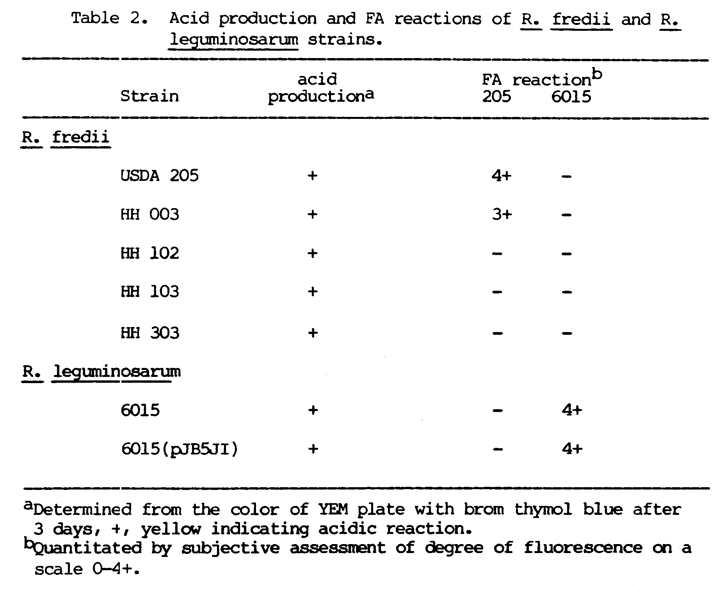

29
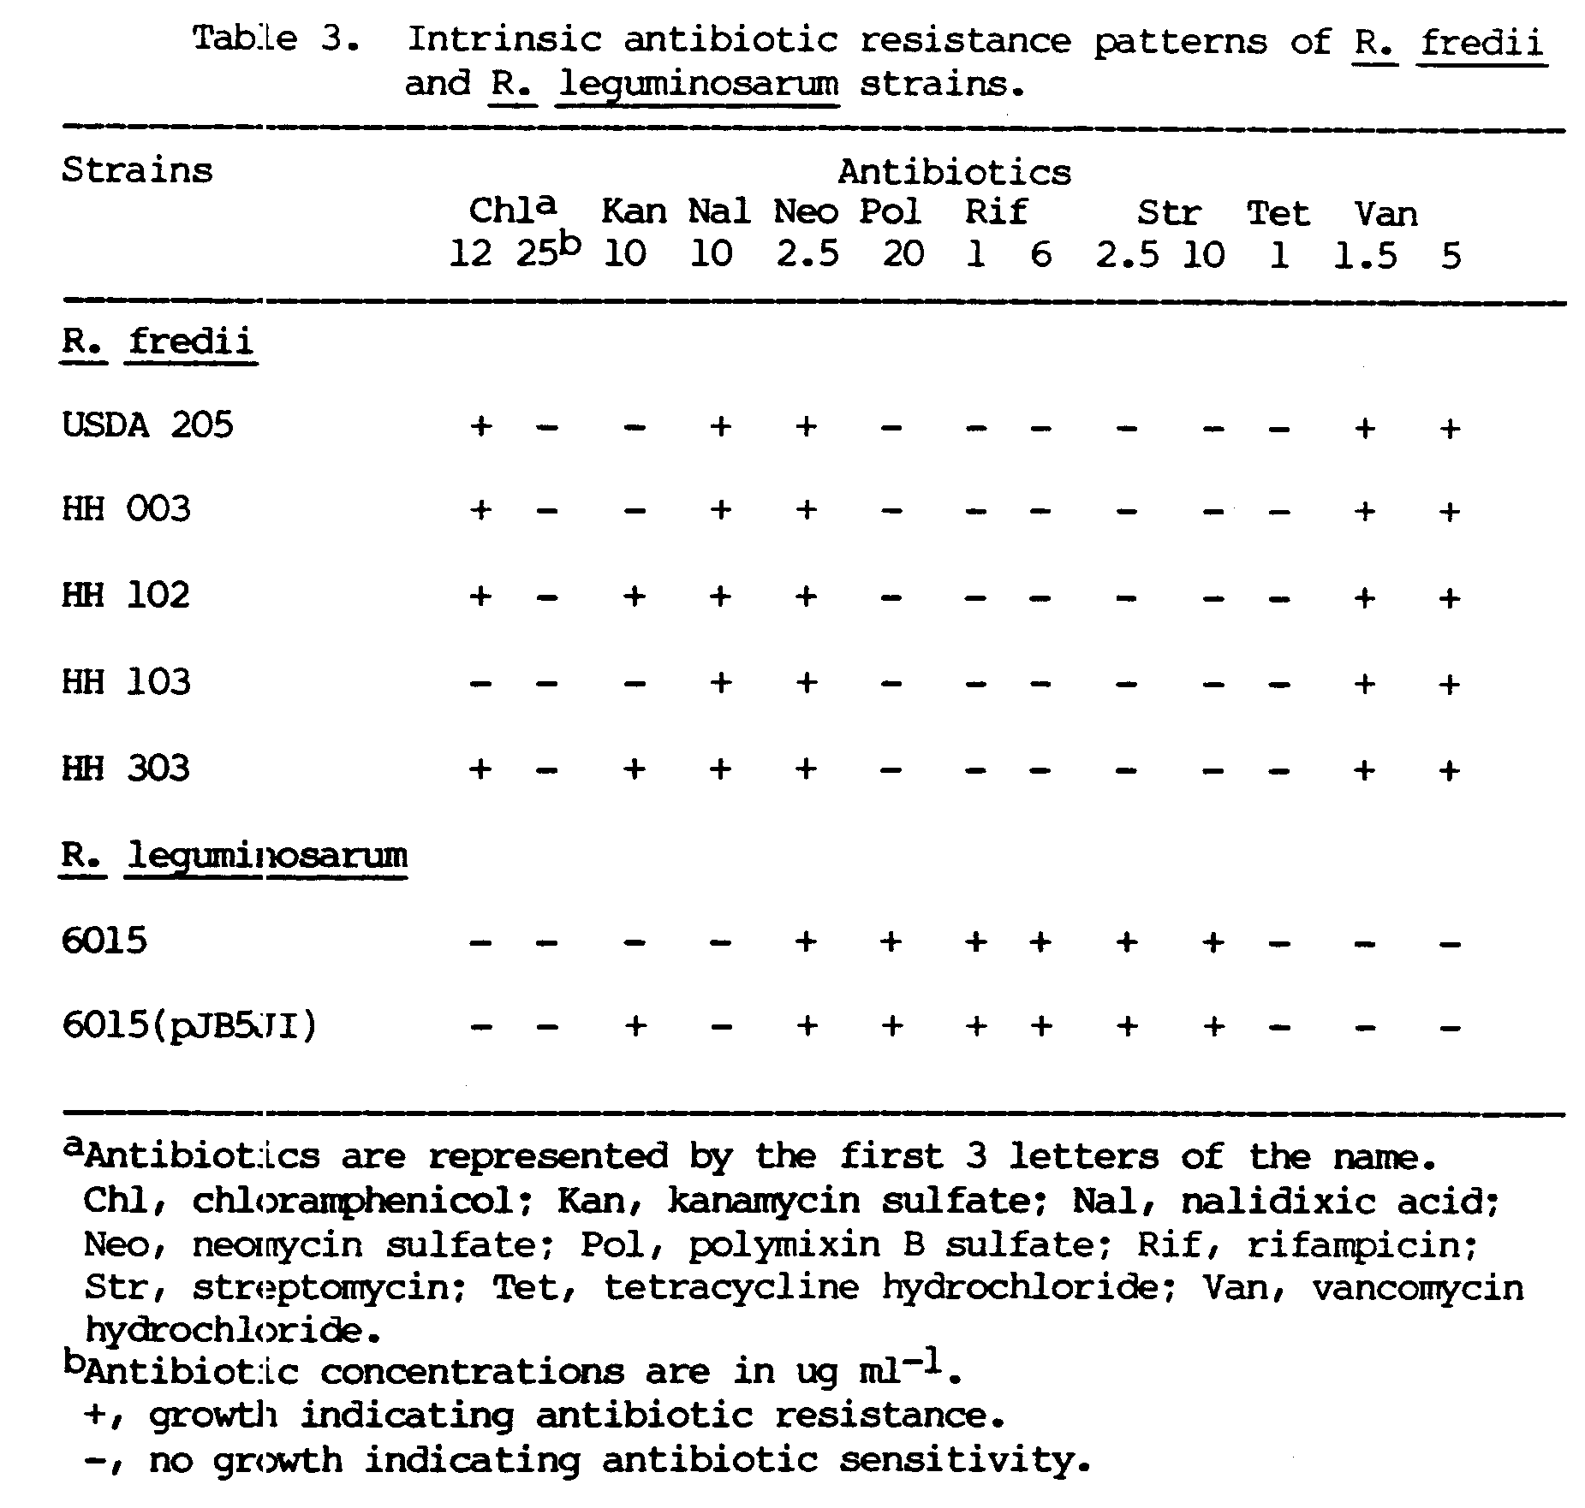

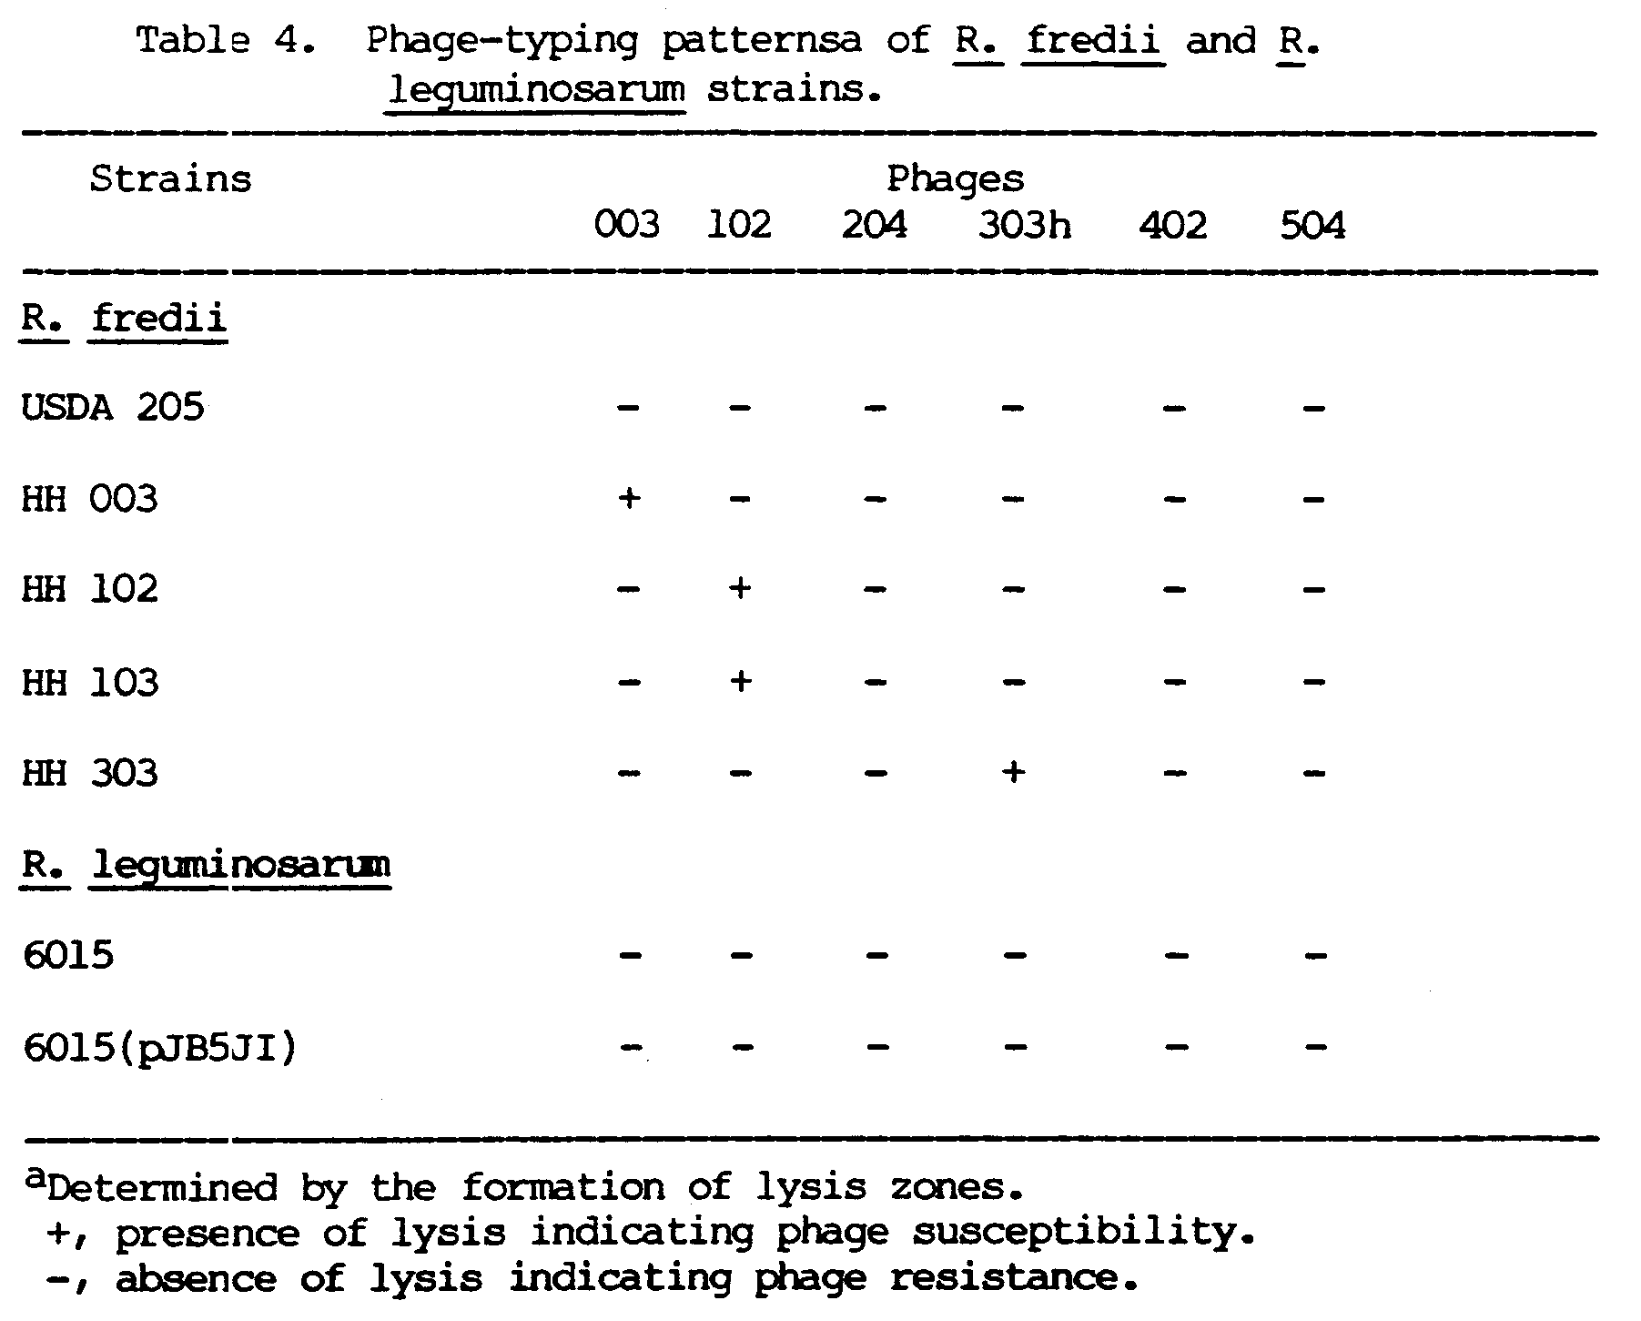

Figure 1. Agarose gel electrophoresis of plasmid DNA from R. fredii. Lane: 1 and 5, R. leguminosarum 6015; 2, USDA 205; 3, R. trifolii T-12; 4, HH 003; 6, HH 102; 7, R. meliloti L5-30; 8, HH 103; 9, R. leguminosarum 6015 (pJB5JI); and 10, HH 303. The numbers refer to the sizes of the plasmids in Mdal. (Picture of HH 003 and reference plasmid is courtesy of M. Kingsley)

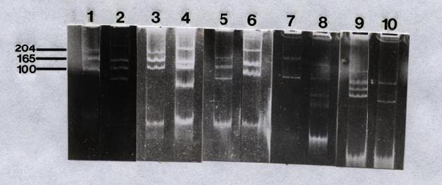

Isolation of plasmid cured-mutants

In order to determine whether genes for symbiotic functions are carried on the plasmids of the R. fredii strains, they were subjected to treatments designed to eliminate the plasmids.
The plasmid-curing experiments resulted in a change in the plasmid profiles of some of the strains. The plasmid cured strains were designated according to the treatments used to produce them. USDA 205-A05 was isolated after exposure to 5 ug ml⁻¹ AO, HH 003-1C40 and HH 003-2C40 after one and two week cycles of growth at 40ºC respectively, and HH 102-AO2T37 after exposure to 2 ug ml⁻¹ AO at 37ºC. As shown in Figure 2, USDA 205-AO5 had lost its third largest plasmid, HH 003-2C40, its second largest plasmid, and HH 102-A02T37, its third largest one. HH003-1C40 lost its second and third plasmids but gained one that showed a lower electrophoretic mobility, possibly as a result of cointegration of two plasmids. There were no differences between the cured strains and their parents with regard to their growth on YEM, FA reaction, IAR pattern, and phage susceptibility (data not shown).

Figure 2. Plasmid profiles of R. fredii cured mutants and parent strains. Lane: 1, USDA 205-A05; 2, USDA 205; 3, HH 003; 4, HH 003-1C40; 5, HH 003-2C40; 6, HH 102; and 7, HH 102-A02T37.

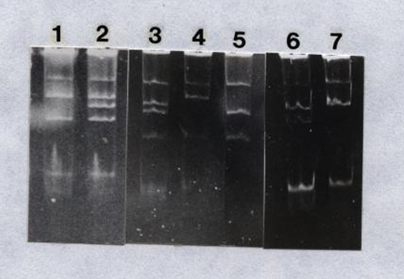
The plasmid-cured strains were tested on host plants and their symbiotic phenotypes are presented in Table 5. Two of the cured strains (USDA 205-A05 and HH 003-2C40) failed to nodulate soybeans while HH 003-1C40 and HH 102-A02T37 formed effective nodules like the parent strains.
HH 103 and HH 303 both failed to develop cured mutants, even after subjecting them to a combined AO-high temperature treatment for five weeks.

Transfer, expression, and maintenance of pSym plasmid

The R. fredii strains were used as recipients of pJB5JI, a 130-Mdal derivative of the conjugative and bacteriocinogenic plasmid pRLIJI from R. leguminosarum into which the transposon Tn5 has been introduced (Beringer et al. 1978). This plasmid encodes five recognizable functions: the host specificity for pea, the nodulation functions, the N₂-fixing ability, the transfer function (tra), and kanamycin resistance (Johnston et al., 1978). The nodulation functions include root adhesion (Roa⁺), hair curling (Hac⁺), and nodule initiation (Noi⁺) (Rolfe et al., 1983). Kanamycin resistance is controlled by Tn5 that was inserted in the genes for medium bacteriocin production (Mbp::Tn5), and is used as a marker to monitor the presence of the plasmid. Hence, selection for the inheritance of pJB5JI by the recipients in the conjugation experiments was for kanamycin resistance.
To determine if the R. fredii strains could be used as recipients of pJB5JI, they were tested for resistance to the kanamycin levels used in the mating experiments. Only HH 102 and HH 303 which showed natural resistance to a low level of kanamycin in their IAR patterns, exhibited growth beyond 10 ug ml^{-l} of kanamycin (Table 6). Resistant colonies of HH 003 were present at 50 ug ml⁻¹ of kanamycin, and precluded the use of the strain in the mating experiments.

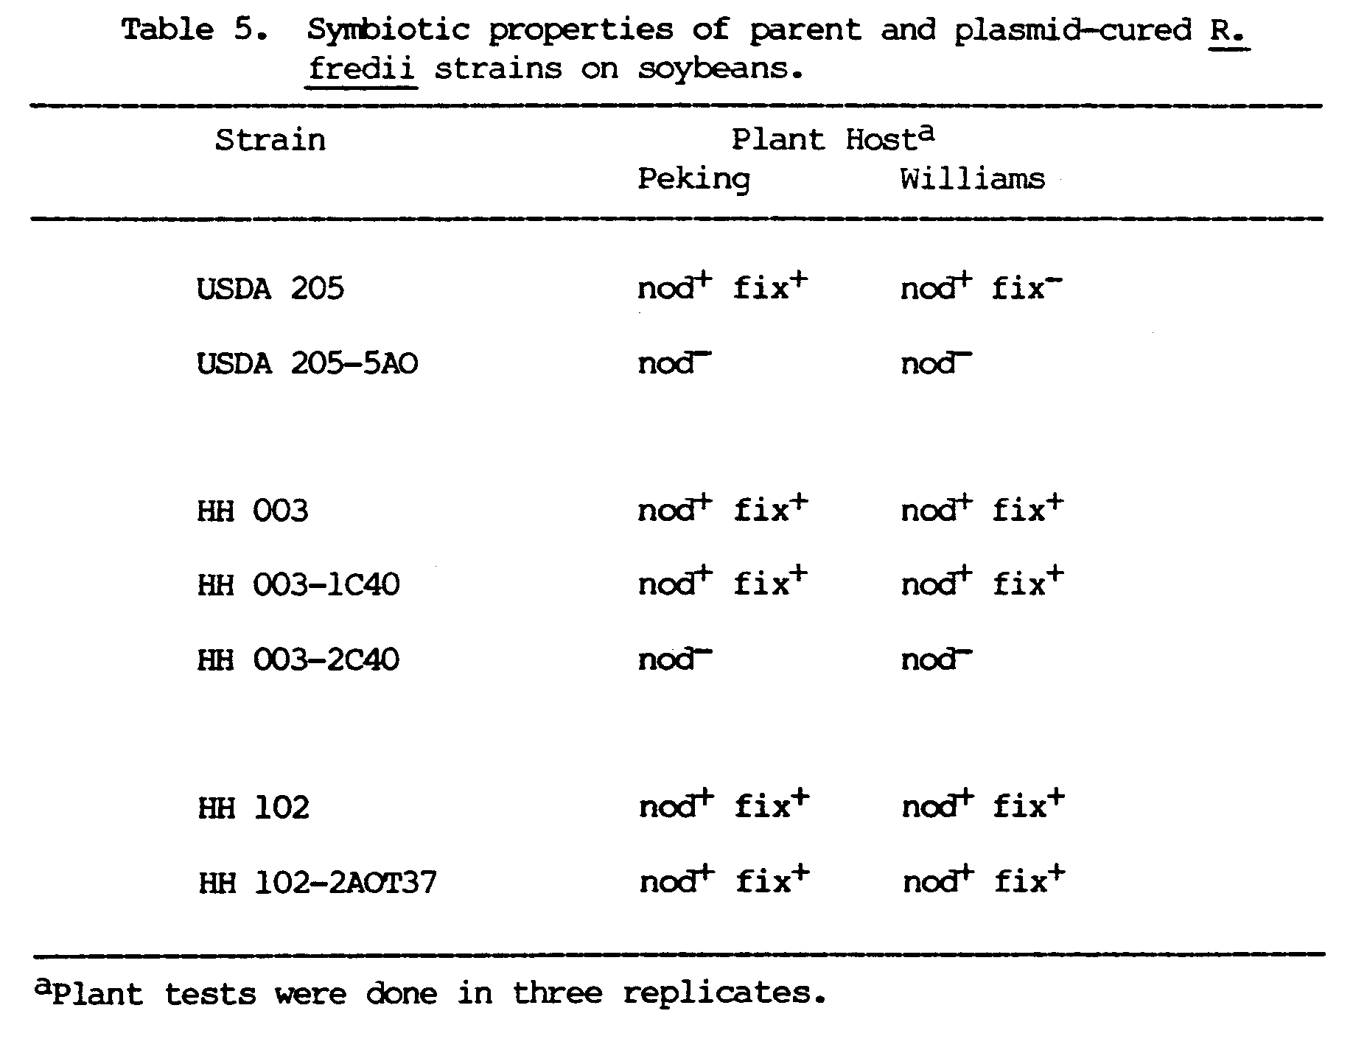

Transfer of pJB5JI
The ability of R. fredii strains to receive, express, and maintain pJB5JI from R. leguminosarum 6015 was studied by using parent and plasmid-cured strains in bacterial conjugation experiments.
The transfer of the Tn5-encoded kanamycin resistance marker occurred at low frequencies (Table 7), with transfer to HH 102 being the highest at 5 X 10⁻⁵, and transfer to USDA 205, the lowest at 2 X 10⁻⁸. Parent strains and their plasmid-cured derivatives had similar transfer frequencies, with USDA 205 and USDA 205-A05 having a frequency of 10⁻⁸ and HH 003 and HH 003-2C40 having a frequency of 10⁻⁷.
Analysis of the plasmid content of the R. fredii transconjugants were made to determine whether their Kan^{r} phenotype was due to an intact pJB5JI, or to spontaneous mutation or transposition of the Tn5 into the chromosome or resident plasmids. Table 8 is a summary of the plasmid content of the R. fredii transconjugants determined from agarose gels, showing the presence or absence of p7B5JI. Three of the transconjugants had acquired a new plasmid band with the same electrophoretic mobility as pJB5JI, three displayed a plasmid band that indicated a plasmid smaller than PJB5JI, and two were indistinguishable from the corresponding recipient strains. Figure 3 presents the plasmid profiles of the USDA 205-AO5 transconjugants, and for reference, those of the wild type USDA 205, the donor R. leguminosarum 6015 (pJB5JI), and the recipient strain USDA 205-AO5.

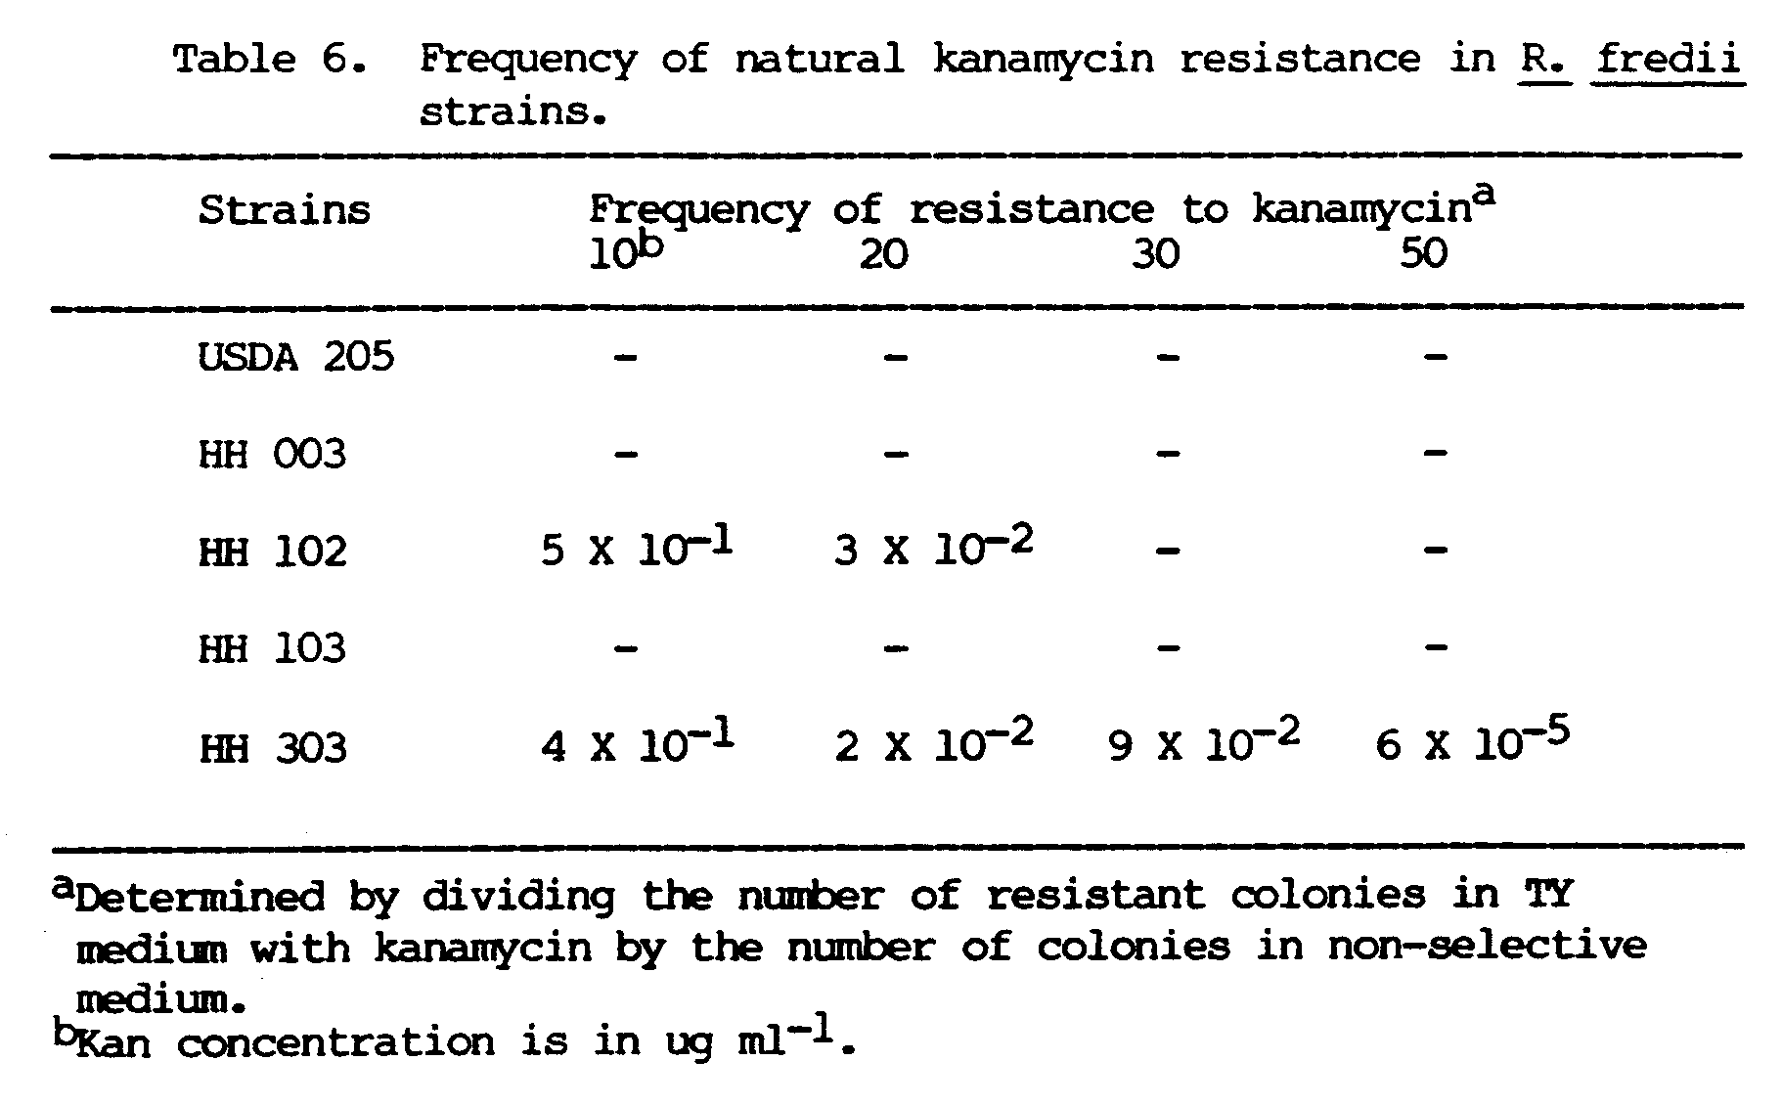

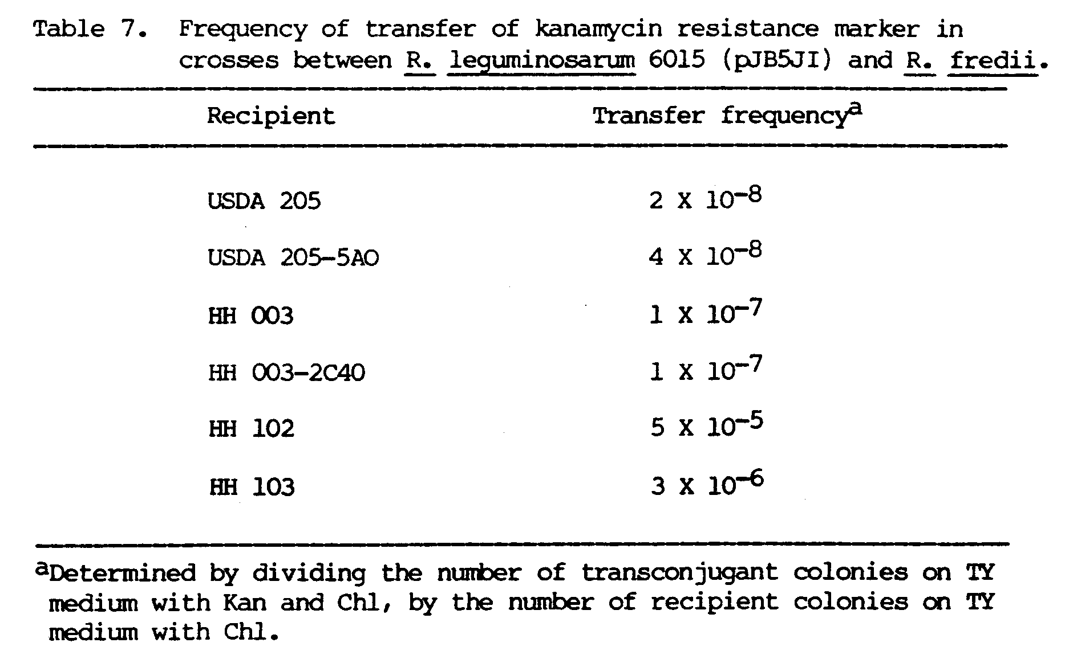

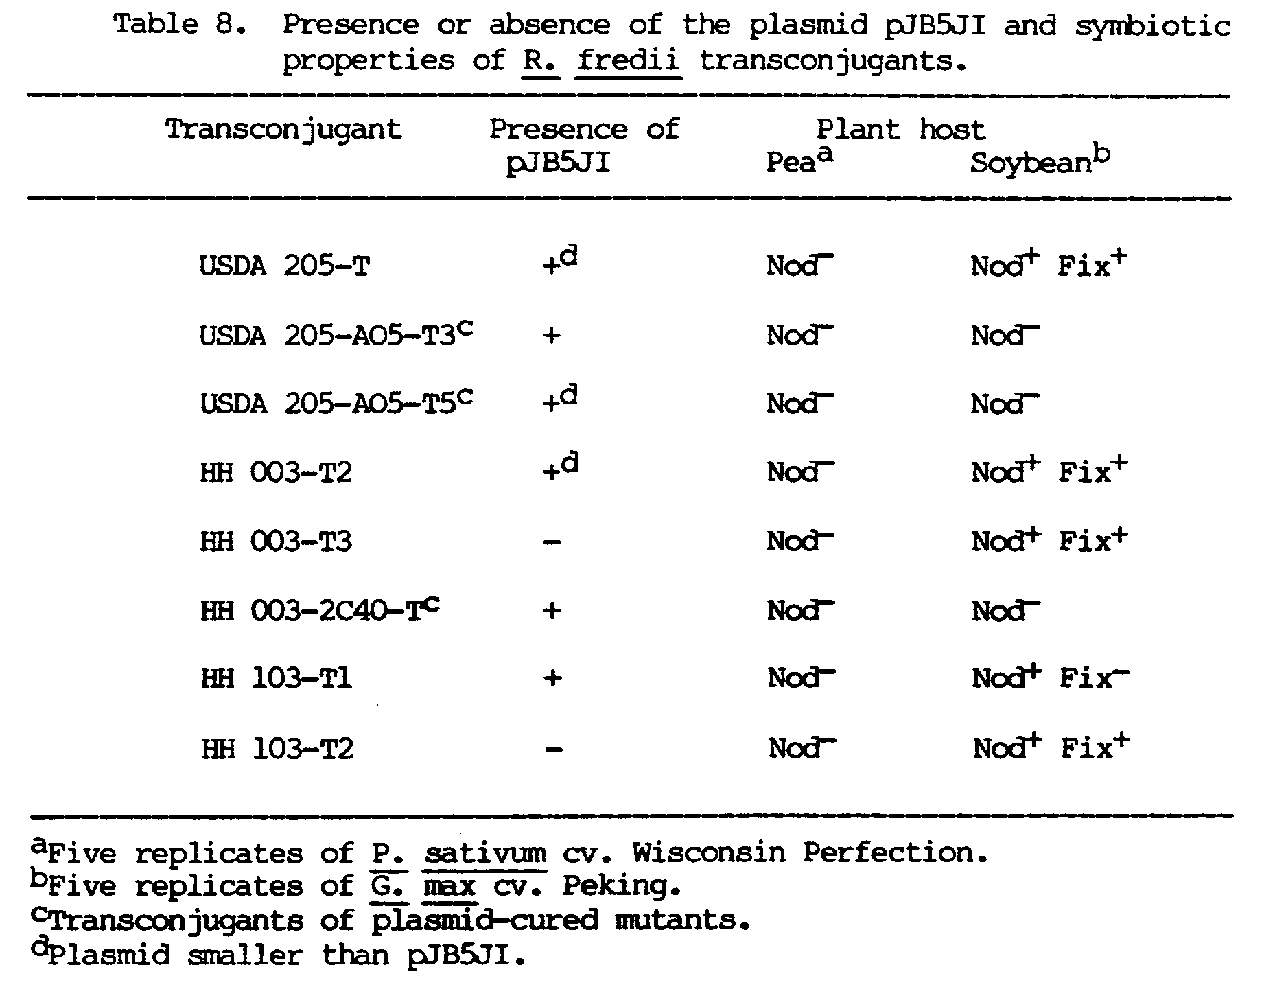

Table 8 also outlines the symbiotic properties of the R. fredii transconjugants. In order to determine the effect of the introduced plasmid genes, plant hosts were used to screen the transconjugants for gene expression. The symbiotic phenotypes of the transconjugants were examined by inoculation of soybean plants, the normal host of R. fredii and pea plants, the host specified by the pJB5JI-encoded genes. None of the R. fredii transconjugants formed nodules on peas. The transconjugants of the plasmid-cured strains still did not nodulate soybeans but those of the parent strains did.
The presence of pJB5JI in the transconjugants was also confirmed by backcrossing them to the Nod⁻ R. leguminosarum 6015. The R. fredii transconjugants were able to transfer the pJB5JI kanamycin marker at relatively higher frequencies, ranging from 10⁻⁴ to 10⁻⁶ (Table 9). The transconjugants of USDA 205 and HH 003, and those of their plasmid-cured derivatives showed similar transfer frequencies of 10⁻⁴.
The R. leguminosarum 6015 transconjugants from the backcrosses had a variety of plasmid profiles (Figure 4). Based on their plasmid make-up, the 6015 transconjugants can be grouped into two categories: those that received an additional band that had similar mobility as pJB5JI and those that did not. Within these two groups, additional variation can be seen. There are four kinds of plasmid profiles in the first group: first, those that resemble 6015 (pJB5JI) (lane 3); second, those that show an additional high mobility plasmid band that comigrated with the linear chromosomal fragments (lane 4); third, those that show two additional plasmid bands (lane 5); and fourth, those that are missing the smallest plasmid of 6015 (lane 6). The group that did not show the pJB5JI plasmid band are of two kinds: those that resembled the recipient strain 6015 (lane 7), and those that have lost the smallest 6015 plasmid (lane 8).

Figure 3. Plasmid profiles of R. fredii USDA 205-A05 transconjugants and reference strains. Lane: 1, USDA 205-A05-T3; 2, USDA 205-A05-T5; 3, USDA 205-A05; 4, USDA 205; and 5, R. leguminosarum 6015 (pJB5JI). Arrow points at plasmid pJB5JI.

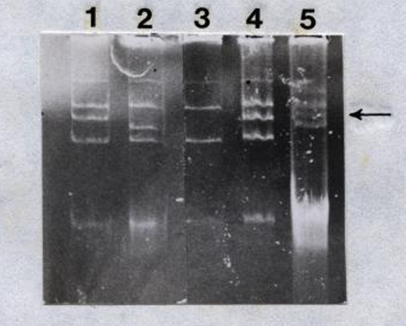
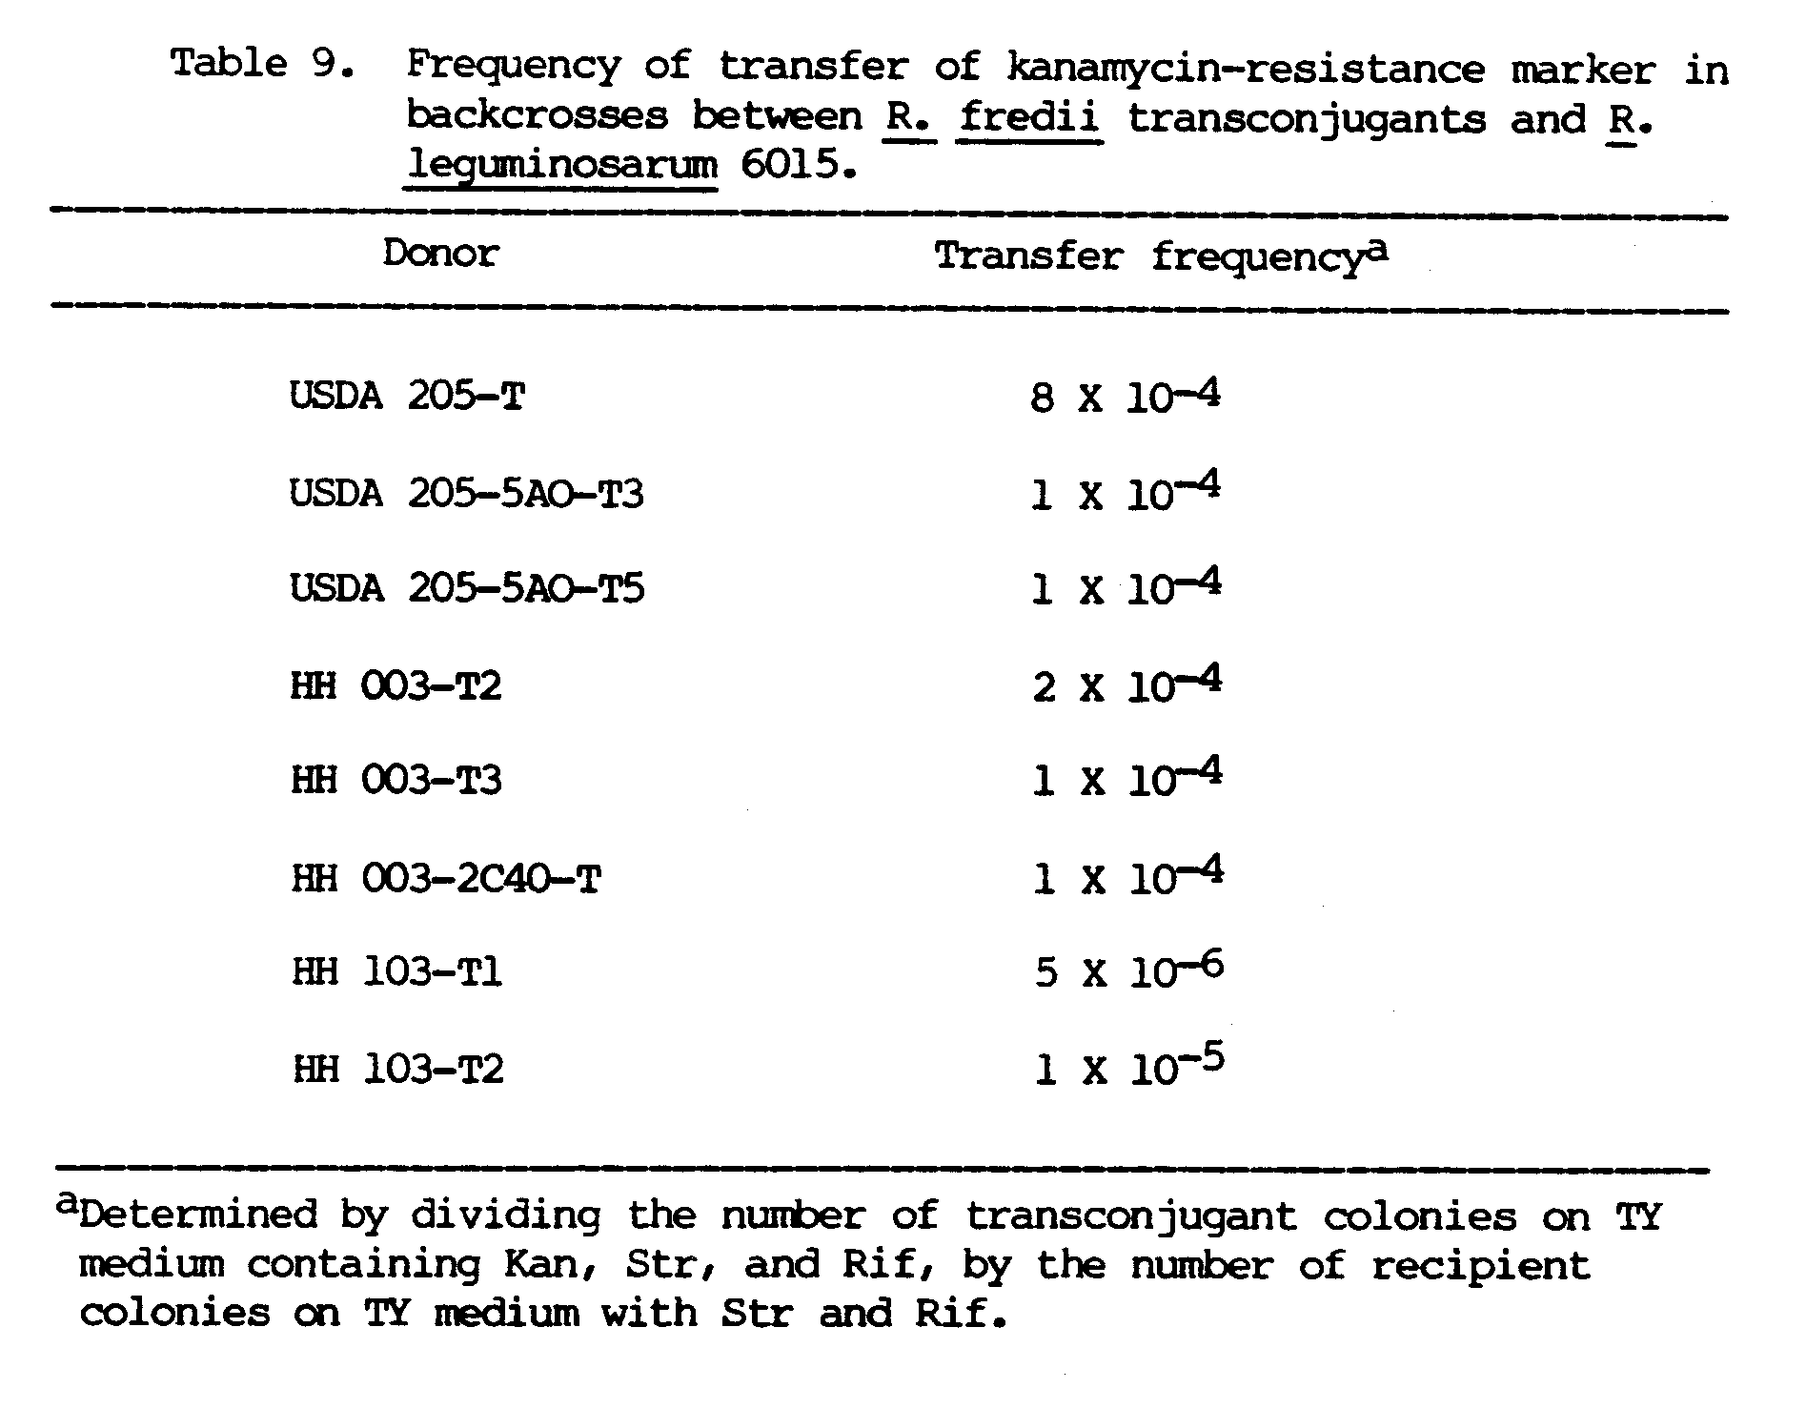

Figure 4. Plasmid profiles of R. leguminosarum 6015 and its transconjugants. Lane: 1, 6015 (pJB5JI); 2, 6015; 3, representative profile of T2 and T7A; 4, T7C; 5, T7B; 6, T5A; 7, representative profile of T1, T3A, T3B, T4, T6, and T8; and 8, T5C. Arrow points at plasmid pJB5JI.

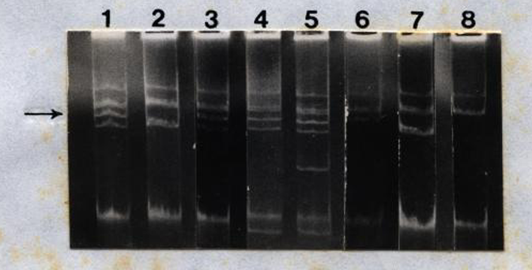

Table 10 presents a summary of the pJB5JI donor, plasmid make-up and symbiotic properties of the R. leguminosarum transconjugants resulting from the backcrosses. None of the transconjugants nodulated soybean plants, and those that did not receive pJB5JI failed to nodulate pea plants as well. The transconjugants with pJB5JI were nodulation competent and formed either effective or ineffective nodules on peas.

Symbiotic effectiveness of transconjugants
The effect of pJB5JI on the nitrogen fixation ability of the nodulation competent R. fredii transconjugants was assessed by comparing their symbiotic performance on soybean plants with those of the wild type parents. As Table 11 shows, the transconjugants exhibited various degrees of effectiveness. While the HH 003 trans-conjugants were identical to the parent strain in all measured parameters of symbiotic effectiveness, USDA 205-T differed significantly from its parent strain in terms of the amount of ethylene produced and shoot dry weight. HH 103-Tl was ineffective in nitrogen fixation, the plants having very small white nodules and the leaves appearing yellow and chlorotic like the uninoculated plants. HH 103-T2 formed effective nodules but differed significantly from the parent strain in the amount of ethylene produced, nodule dry weight and shoot weight.

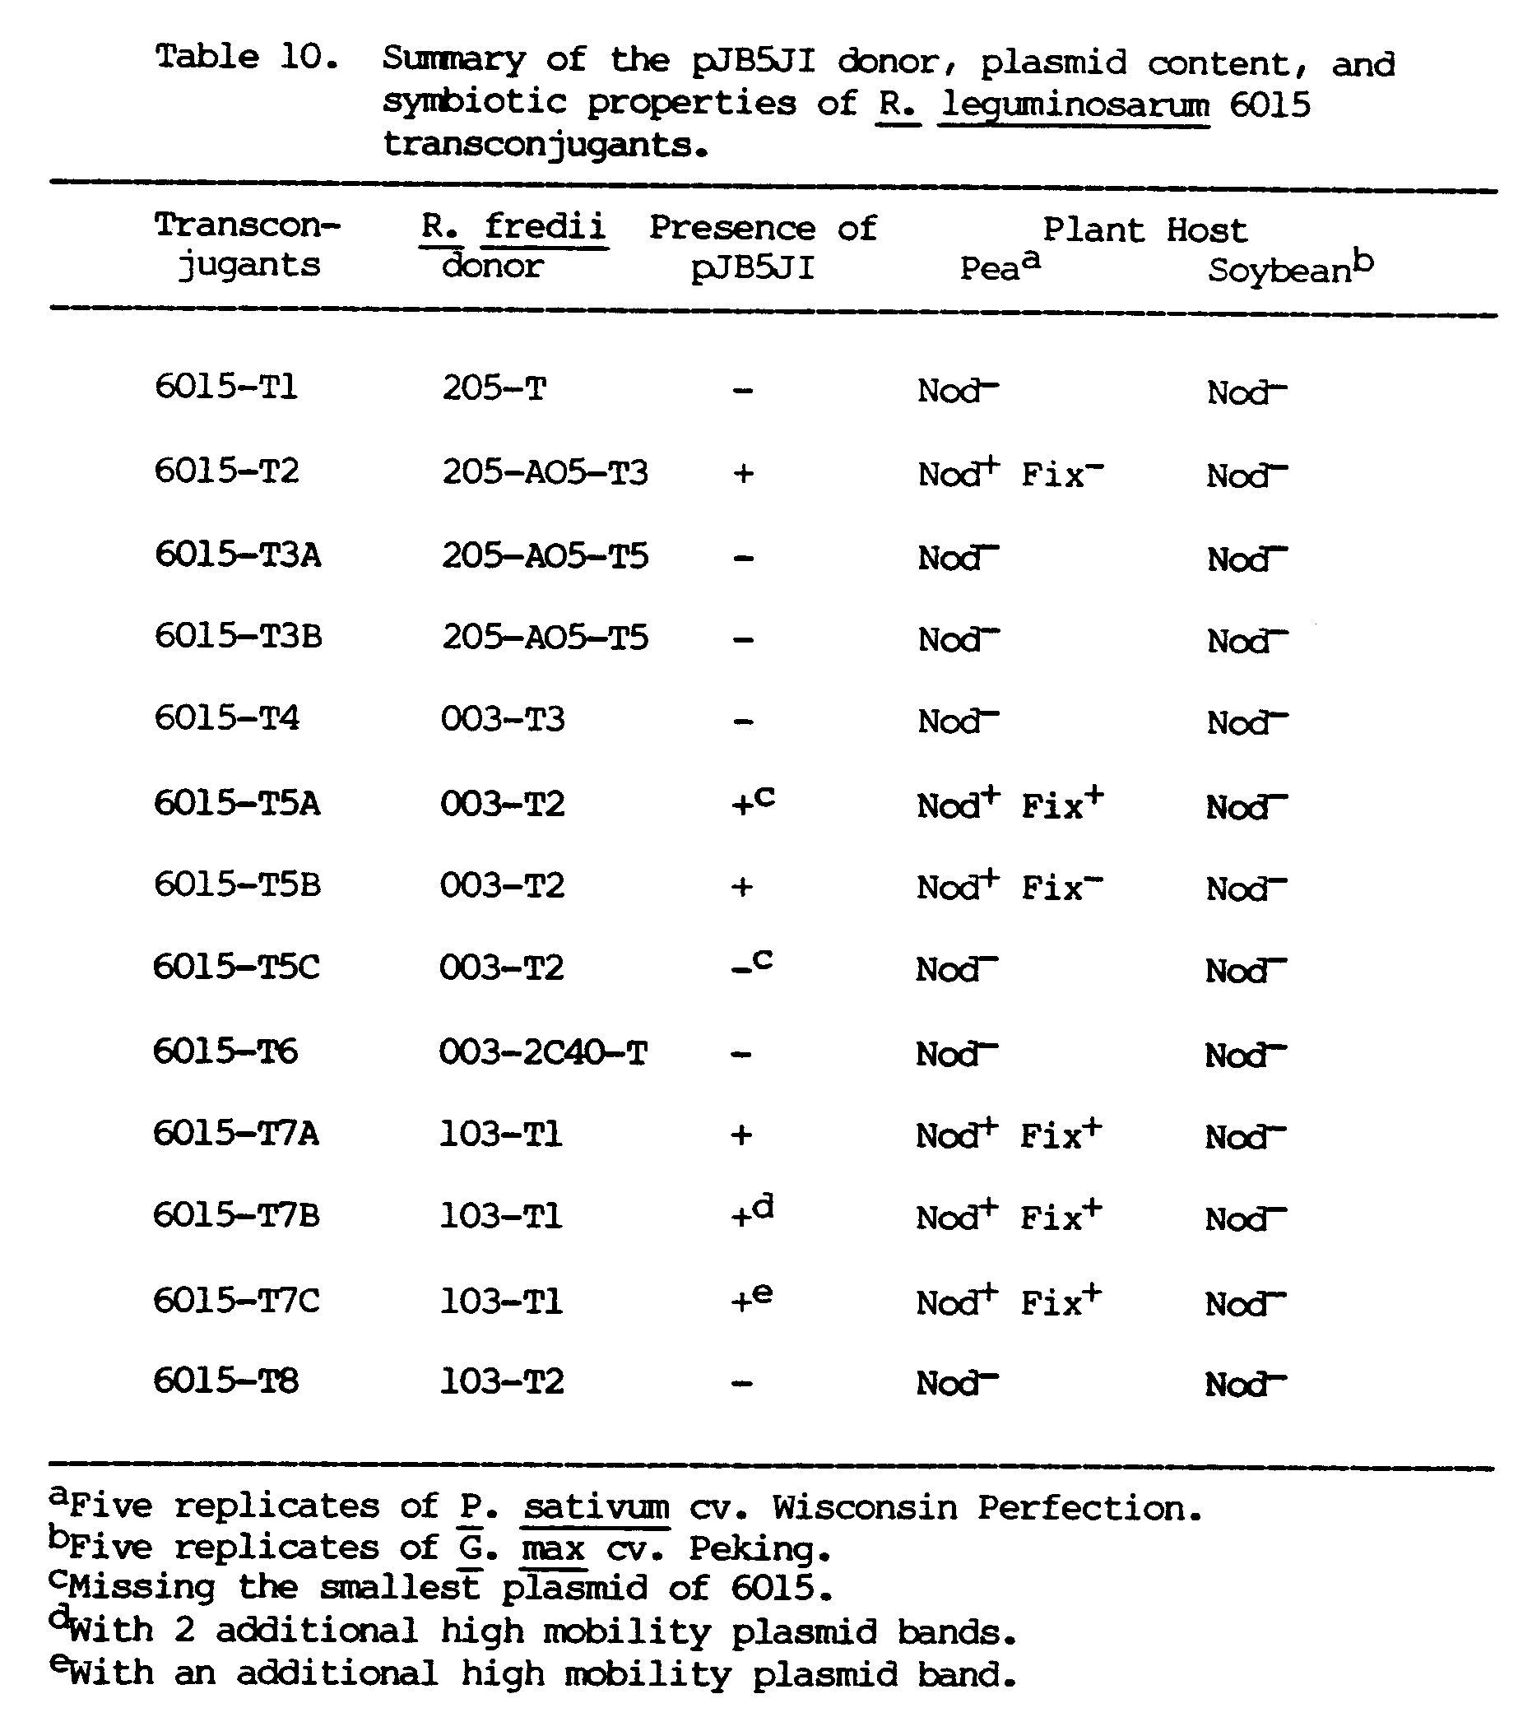

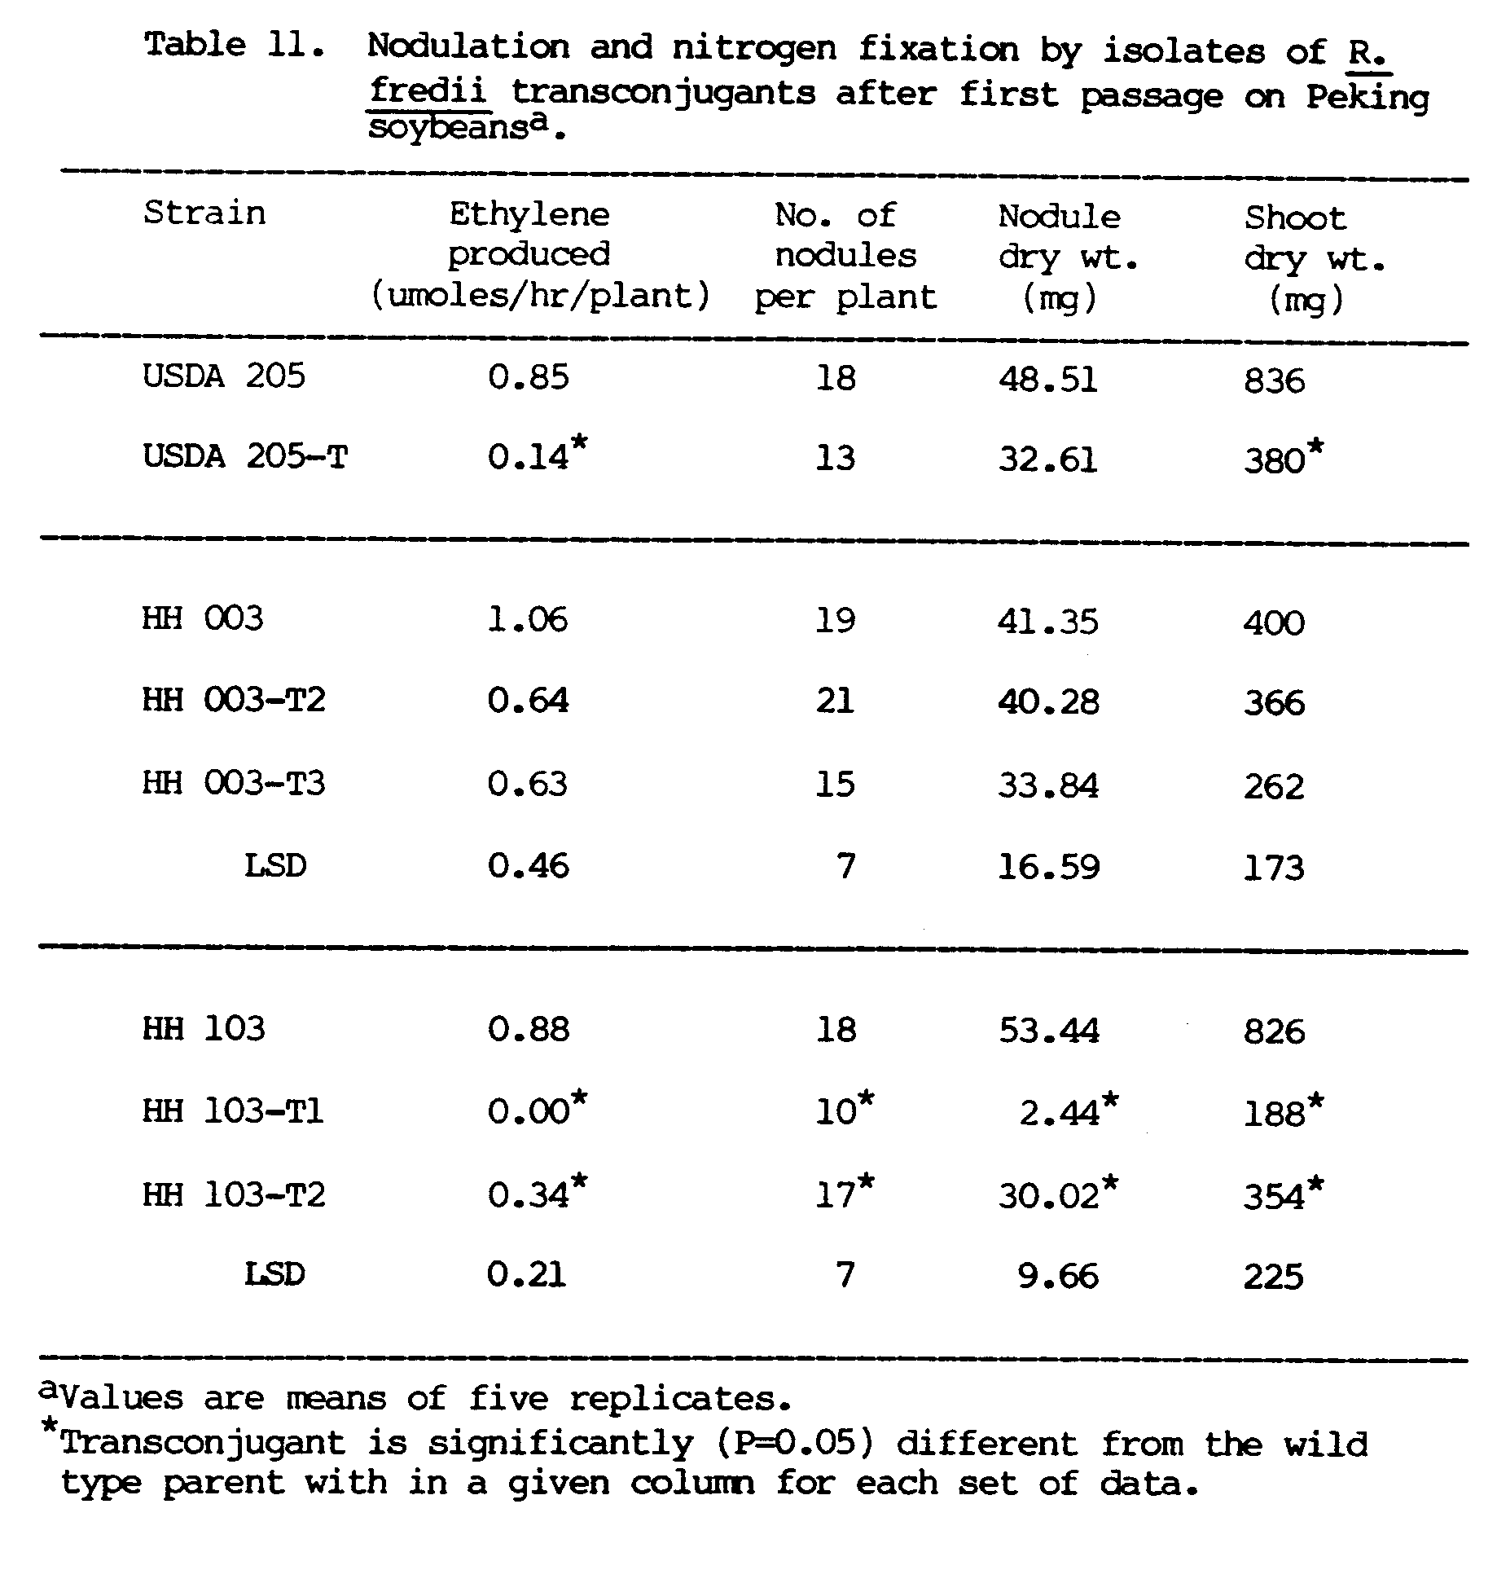

On the second passage through pea and soybean plants, the reisolated transconjugants still did not nodulate peas, but retained their ability to nodulate soybeans. Table 12 presents the symbiotic performance of the R. fredii transconjugants on second passage on soybean plants. USDA 205-AO5-T still differed significantly from its parent strain, but this time in all the observed parameters. The two transconjugants of HH 003 were as effective as the parent, except in terms of shoot dry weight. HH 103-T1 formed effective nodules but differed significantly from the parent in nodule dry weight and shoot dry weight.
The reisolated transconjugants retained their antibiotic markers, and there were no detectable changes in their plasmid profiles (data not shown).

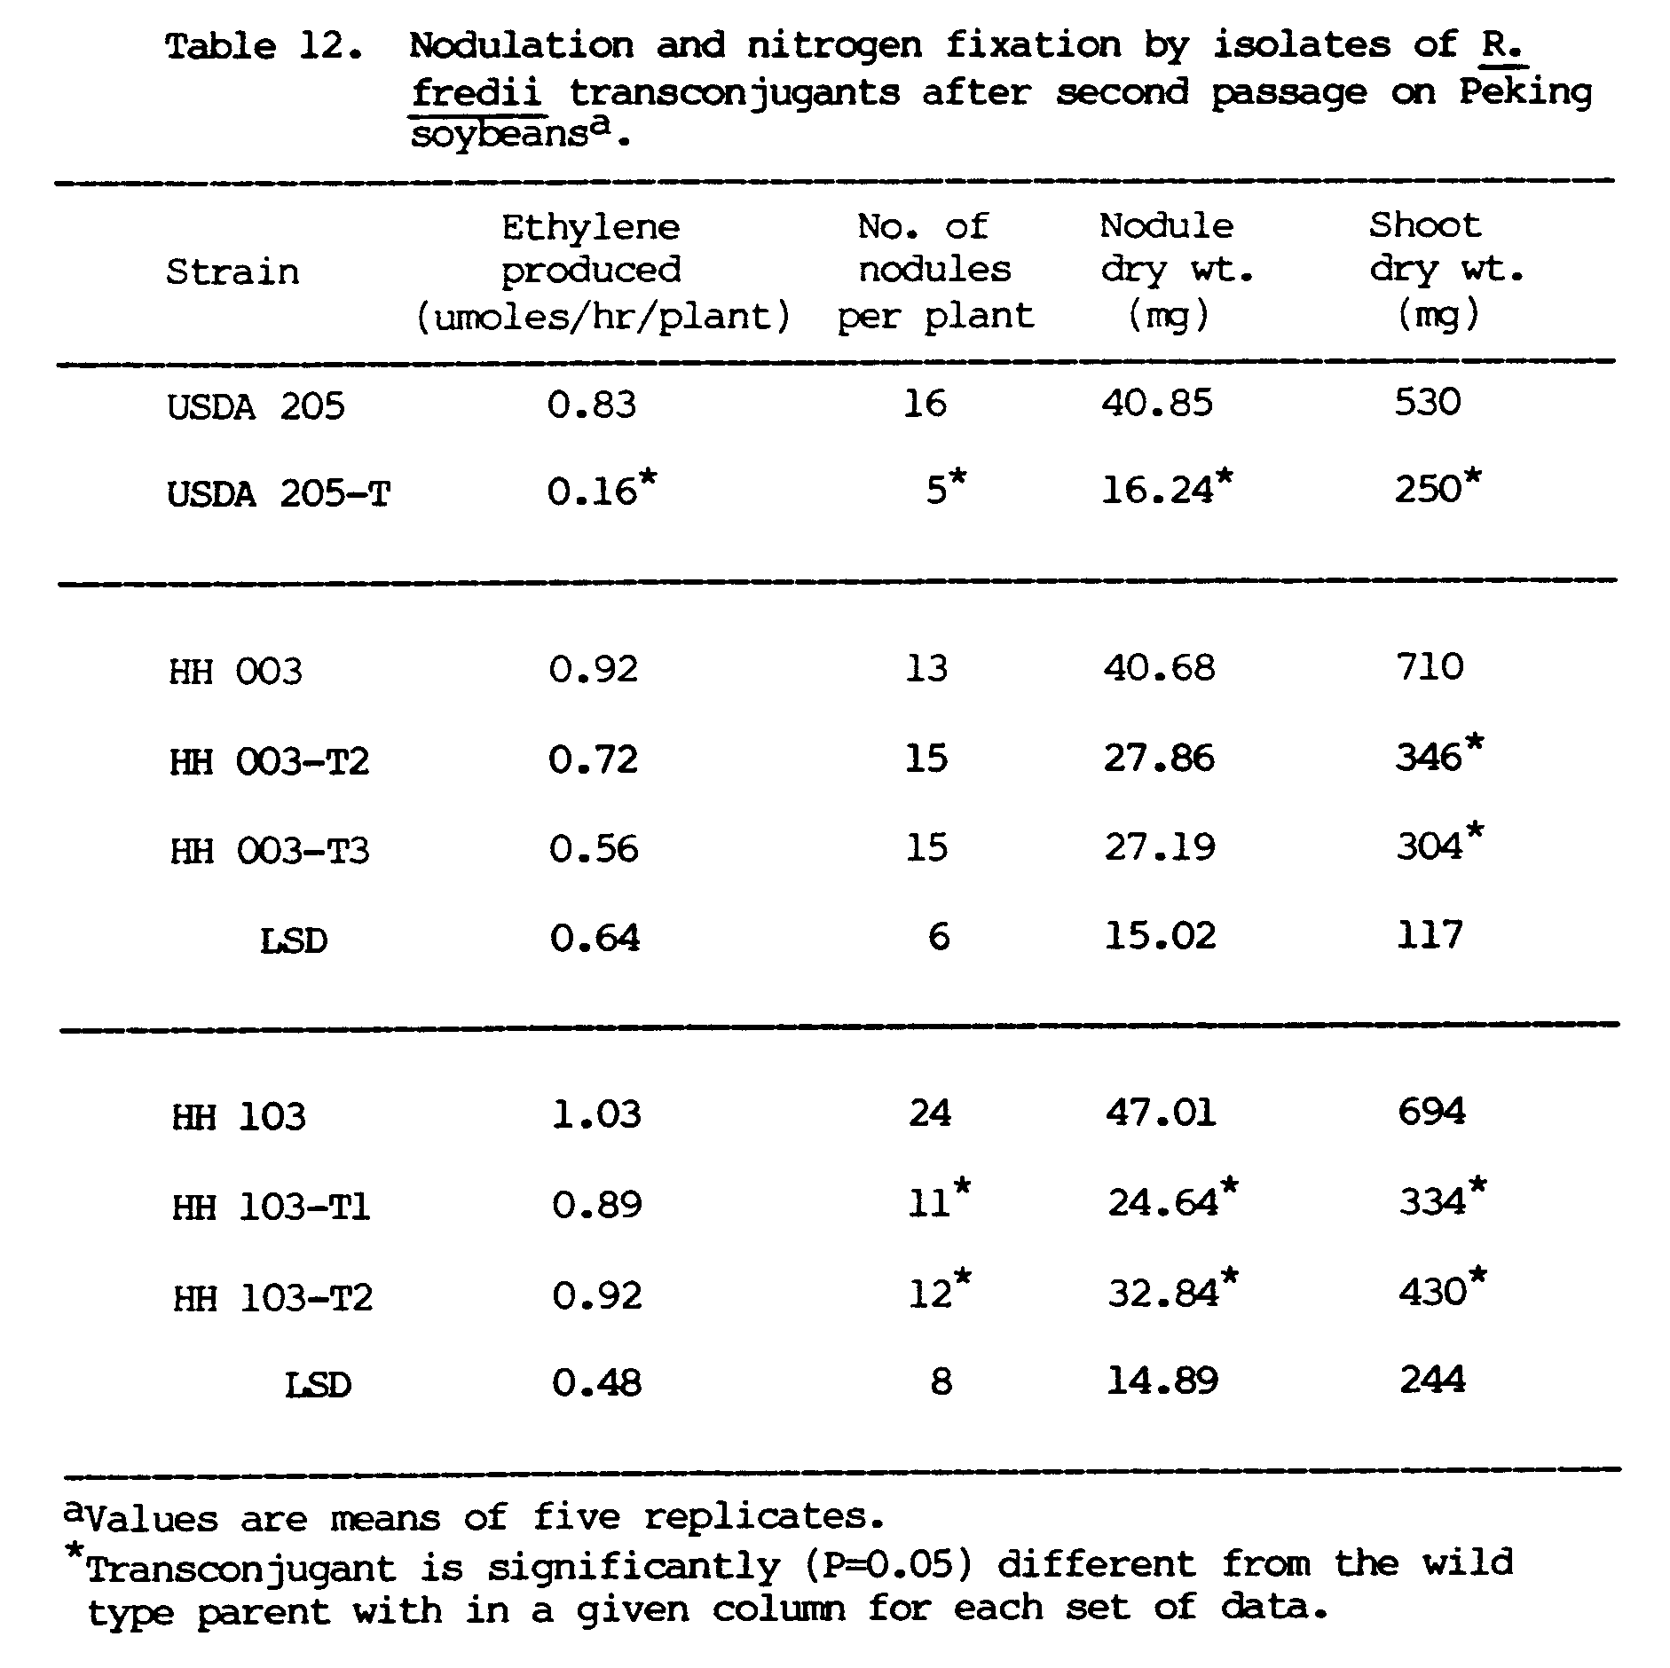

CHAPTER 4
DISCUSSION
This study confirms and extends earlier studies that showed the presence of large indigenous plasmids in R. fredii and their involvement in determining symbiotic properties.
Each of the R. fredii strains examined contained high molecular weight plasmids and all can be differentiated on the basis of their plasmid profiles. The plasmid profile of the type strain USDA 205, consists of four plasmid bands and is identical to that of other studies (Appelbaum et al., 1985a; Broughton et al., 1984; Masterson et al., 1985). Previous work on this strain showed three plasmid bands ranging from 57 to 192 Mdal in size (Masterson et al., 1982; Sadowsky and Bohlool, 1983). By using a plasmid isolation procedure that is more sensitive to large covalently closed circular DNA molecules, a fourth band of lower electrophoretic mobility that is estimated to be greater than 300 Mdal, was detected. Heron and Pueppke (1984) reported a 35-Mdal plasmid in addition to these four, but it was not seen consistently in this study and could not easily be distinguished from the band of linear chromosomal fragments.
The presence of megaplasmids in USDA 205 and the HH strains (except HH 303), and in other strains as well (Appelbaum et al., 1985a; Broughton et al., 1984) suggests that it may be a common feature in R. fredii as it is in R. meliloti, R. trifolii, and R. leguminosarum (Denarie et al., 1981a).
Various intercalating agents, particularly acridines, inhibit plasmid replication without inhibiting chromosomal replication. After exposure to acridine orange, USDA 205-A05 lost its third largest plasmid, and along with it, the ability to nodulate its soybean host. This indicated the involvement of the missing plasmid in the symbiotic functions.
Physical studies of this 112-Mdal plasmid, designated pRjaPRC205b by Masterson et al. (1982), show the presence of genes for nodulation and nitrogen fixation. The presence of nod genes was indicated by hybridization with pRmSL26, a cosmid clone that contains a 20-kb insert of R. meliloti DNA having several nod genes (Long et al., 1982; Appelbaum et al., 1985a), and with pRs23, a plasmid containing nod sequences from a Rhizobium strain that nodulates tropical legumes and the nonlegume Parasponia (Djordjevic et al., 1985a). The genes for nitrogen fixation were located by hybridization with pRmR2, a recombinant R. meliloti plasmid with a 3.9-kb EcoRI fragment homologous to the nifD and nifH genes in K. pneumoniae (Masterson et al., 1982; Ruvkun and Ausubel, 1980). Multiple copies of the nod and nif sequences on this 112-Mdal plasmid was reported by Prakash and Atherly (1984).
The nod genes are duplicated in two other plasmids in USDA 205. Appelbaum et al. (1985a) reported that the 192-Mdal and 57-Mdal plasmids also carry nod genes, since they also hybridized with pRmSL26. Sadowsky and Bohlool (1983) have shown that elimination of the 192-Mdal plasmid resulted in the loss of nodulation ability. From these studies, it appears that in USDA 205, the remaining gene copies after plasmid curing cannot compensate for the loss of the plasmid, and leads to the loss of the symbiotic function.
However, in studies of another R. fredii strain, USDA 206, curing of a 197-Mdal plasmid carrying both nif and nod genes did not result in the loss of any symbiotic functions, but to a reduction of nodulation and nitrogen fixation performance (Mathis et al., 1985). Barbour et al. (1985) suggested the presence of other functional nif genes in the chromosome and in another plasmid, but the duplicate nod genes that are responsible for the retention of the nodulation function were not located.
Prolonged exposure to elevated temperatures is another factor that results in the loss of plasmids, and it was postulated that this was due to its effect on the temperature sensitive plasmid replication process (Zurkowski, 1982). After seven days of heat treatment, HH 003-1C40 had two missing plasmid bands, but gained a new band of lower mobility. The large size of the new plasmid indicates that it may be a cointegrate of two plasmids. The formation of effective nodules by HH 003-1C40 on soybeans shows that functional nod genes are still present.
HH 003-2C40 lost its second largest plasmid after a two-week cycle of growth at high temperature. The loss of this large plasmid, which comigrated with the 460-Mdal megaplasmid of R. trifolii T-12 (Zurkowski and Lorkiewicz, 1979) resulted in the loss of the ability to nodulate soybeans. This points to a megaplasmid as the possible location of symbiotic genes. This is unusual because, in R. fredii, nodulation and nitrogen fixation genes are generally known to be carried on 150-200 Mdal plasmids (Broughton et al., 1984; Masterson et al., 1982). In studies done by Appelbaum et al. (1985a), hybridization experiments using nif and nod probes on R. fredii plasmids failed to show homology with the megaplasmids, but did so with the medium-sized plasmids in eight strains and with the chromosome in two strains.
The third largest plasmid of HH 102-A02T37 appears to be a cryptic plasmid. Its loss did not affect the symbiotic performance of the strain, and its functions are unknown.
Like previous work done by Sadowsky and Bohlool (1985), the results of the plasmid-curing experiments correlate the absence of nodulation ability with the loss of plasmids. However, the nature of the changes in the nodulation process effected by the plasmid loss remains to be defined.
At least one of the plasmids of HH 103 is transmissible to R. leguminosarum 6015. The transfer of pJB5JI from the transconjugant HH 103-T1 to 6015 resulted in the appearance of two new plasmid bands, in addition to the pJB5JI plasmid band (Figure 4, lane 5). The larger of the two new plasmids appears to be one of the plasmids of HH 103-T1 since it showed similar electrophoretic mobility. There is no plasmid band in HH 103-T1 that corresponds to that of the smaller plasmid indicating that this may not have been previously detected or may represent one of the native plasmids that suffered a deletion.
The R. leguminosarum plasmid, pJB5JI, is transmissible between different strains of R. leguminosarum, R. trifolii, and R. phaseoli at high frequency, occurring at 10⁻² per recipient (Johnston et al., 1978). In the same study, the establishment of the plasmid-linked markers in R. meliloti was lower at 10-⁴ per recipient. The R. fredii strains in this study are able to conjugate with R. leguminosarum and act as recipients of pJB5JI at low frequencies (10⁻⁵ to 10⁻⁸). Studies of other strains showed higher frequencies ranging from 10⁻² to 10⁻⁵ (Ruiz-Sainz et al., 1984; Sadowsky, 1983), except in the case of USDA 205. The transfer frequency of USDA 205 in this study was slightly higher than that of Sadowsky (1983), which showed a low 10⁻⁹ transfer frequency of the kanamycin marker. Transfer of pJB5JI from the R. fredii transconjugants back to R. leguminosarum occurred at frequencies that are similar to those obtained by Sadowsky (1983) at 10⁻⁴ per recipient.
Whether the R. fredii recipient had its normal complement of plasmids or not, transfer frequency remained the same for both the parent and the plasmid-cured derivative. This indicates the lack of an entry exclusion function on the missing plasmids.
The inability of the kanamycin resistant R. fredii transconjugants to form nodules on peas may have a number of causes. First, the transconjugants may not have received all the pJB5JI genes necessary for nodulation. This is indicated by the fact that some of the plasmid profiles show a plasmid smaller than pJB5JI or none at all. It is therefore possible that only a part of the Tn5-carrying plasmid was transferred. This is confirmed by the results of the backcrosses to the Nod⁻ R. leguminosarum 6015 wherein only some of the 6015 transconjugants regained the ability to form effective nodules on peas. The results also indicate that there may have been varying sizes of the deletions suffered during the transfer, some of which are too small to be discernible in the plasmid profiles. This is evidenced by the range of phenotypes exhibited by the 6015 transconjugants.
Secondly, although the R. leguminosarum genes were transferred with the pJB5JI, they were not expressed in the R. fredii genetic background. Earlier work by Sadowsky and Bohlool (1985) showed the lack of function of pJB5JI genes in R. fredii strains.
The presence of the plasmid pJB5JI in the plasmid-cured transconjugants did not enable them to nodulate peas, nor did it restore their ability to nodulate soybeans. The R. fredii 205-A05-T transconjugant received intact nod genes as confirmed by the Nod⁺ Fix⁻ phenotype of the 6015 transconjugant that resulted from the backcross, yet the introduction of the plasmid did not replace the genetic information needed by the recipient to nodulate its normal host. In one study, pJB5JI transconjugants of a cured Nod⁻ R. trifolii strain formed effective nodules on peas, and later formed ineffective nodules on clover (Sadowsky and Bohlool, 1985). This is consistent with the known taxonomic relationship of the species, considering the high degree of genetic homology between R. trifolii and R. leguminosarum. In the case of the more distantly related R. meliloti, Fisher et al. (1985) reported that several nodulation genes are functionally replaceable by a cloned nod gene DNA fragment from R. trifolii and that R. meliloti clones like-wise complement two R. trifolii Nod⁻ mutants. The introduction of pJB5JI to a Nod⁻ R. meliloti that suffered a deletion during heat treatment enabled the transconjugant to form ineffective nodules on alfalfa (Banflavi et al., 1981). In the other Nod⁻ mutants tested, no restoration of the nodulation ability was found.
In this study, the failure of the plasmid-cured transconjugants to regain their nodulation ability with pJB5JI, may indicate that the symbiotic genes lost through the curing process were too substantial, and thus, not replaceable by the common nod genes. It may also indicate that R. fredii represents a genetically separate class of fast-growing rhizobia and the nod genes are too evolutionarily diverged to allow complementation.
As in the case of the transconjugants of the plasmid-cured derivatives, there was no observable expression of the PJB5JI host range genes by the transconjugants of the parent strains. Using other R. fredii strains, Sadowsky and Bohlool (1985) reported similar results, but Ruiz-Sainz et al. (1984) observed swellings on pea roots which microscopically resembled the early stages of nodule development.
The presence of pJB5JI elicited different effects on the symbiotic performance of the Nod⁺ R. fredii transconjugants on soybeans. Some transconjugants formed effective nodules comparable to the wild-type strains, some showed a reduction in their N₂-fixing effectiveness while one transconjugant strain did not fix nitrogen at all.
Johnston et al. (1978) suggested that the presence of genetic information for the nodulation of host plants of different cross inoculation groups in the same Rhizobium strain might cause the strain to be impaired in its nodulation on either host. It is postulated that this phenomenon might be due to some form of functional interference occurring between the two plasmids specifying nodulation for different host legumes. Beynon et al. (1980) observed that inoculation with a strain that contained both the R. phaseoli nodulation plasmid and pJB5JI resulted in the recovery of clones from pea nodules that either suffered a subtantial deletion in the R. phaseoli nodulation plasmid or else lost it completely. This suggested that genetic information on this plasmid had to be eliminated spontaneously before nodulation specified by the R. leguminosarum plasmid pJB5JI could proceed normally. According to Nadler (1984), genes in the symbiotic region of pJB5JI inhibited nodulation of soybeans by R. fredii strains. USDA 205 (pJB5JI) transconjugants induced nodules poorly on roots of Peking soybeans whereas transconjugants containing a plasmid derived from pJB5JI by a 20-Mdal deletion removing the symbiosis genes induced nodules similar to those of the parental USDA 205.
In this study, the symbiotic properties of the HH 103 transconjugants (Table 8) show the plasmid effect. HH 103-T1, which received the intact pJB5JI, was Fix⁻, while HH 103-T2, which has kanamycin resistance but no pJB5JI, was Fix+. These results show that there is functional interference between the symbiotic genes, and further indicate that the impairment of the symbiotic process may extend to N₂-fixing effectiveness as well.
Transconjugants isolated from the soybean nodules retained their antibiotic resistance markers, but showed changes in their symbiotic properties when used in a second cycle of plant inoculation. This may indicate that gene expression has been modified during nodule development. The observation that a Fix⁻ transconjugant in the first cycle of inoculation regained its effectiveness in the second cycle points to the relative instability of pJB5JI. The variable stability of pJB5JI in different strains of R. trifolii was reported by Sadowsky and Bohlool (1985). In their study, reisolates of transconjugants from pea and clover nodules exhibited a range of symbiotic properties. Similar behavior of the Fix⁺ phenotype of wild-type R. trifolii strains carrying pJB5JI was reported previously by Djordjevic et al. (1982).
The reisolated transconjugants retained their antibiotic resistance markers, and showed the same plasmid profiles, suggesting that the plasmid is maintained without gross alterations. However, since there were differences of symbiotic effectiveness of the transconjugants after passage through the host plants, there may have been alterations in the plasmid that were not detected in the agarose gels.
In summary, this study shows that high molecular weight plasmids that are involved in the control of symbiotic functions, together with others whose functions are not known, are an integral part of the genetic make-up of R. fredii strains. The loss of symbiotic functions is correlated with the loss of plasmids. These strains are capable of accepting and maintaining pJB5JI, a pSym plasmid from R. leguminosarum. Although pJB5JI plasmid genes are not expressed, they appear to affect the expression of R. fredii symbiotic genes.

LITERATURE CITED

Adams, M.H. 1959. Bacteriophages. Interscience, New York.

Appelbaum, E.R., E. Johansen, and N. Chartrain. 1984. Identification of plasmids carrying symbiotic genes in fast-growing Rhizobium japonicum using DNA hybridization and Tn5 mutagenesis, p. 670. In: C. Veeger and W.E. Newton (ed.), Advances in nitrogen fixation research. Nijhoff/Junk, The Hague.

Appelbaum, E.R., E. Johansen, and N. Chartrain. 1985. Symbiotic mutants of USDA 191, a fast-growing Rhizobium that nodulates soybeans. Mol. Gen. Genet. 201: 454-461.

Appelbaum, E.R., T.J. McLoughlin, M. O'Connell, and N. Chartrain. 1985. Expression of symbiotic genes of Rhizobium japonicum USDA 191 in other rhizobia. J. Bacteriol. 163: 385-388.

Banfalvi, Z., V. Sakanyan, C. Koncz, A. Kiss, I. Dusha, and A. Kondorosi. 1981. Location of nodulation and nitrogen fixation genes on a high molecular weight plasmid of R. meliloti. Mol. Gen. Genet. 184: 318-325.

Berg, D.E., and C.M. Berg. 1983. The prokaryotic transposable element Tn5. Biotechnology 1: 417-435.

Beringer, J.E. 1974. R factor transfer in Rhizobium leguminosarum. J. Gen. Microbiol. 84: 188-198.

Beringer, J.E., J.L. Beynon, A.V. Buchanan-Wollaston, and A.W.B. Johnston. 1978. Transfer of the drug resistance transposon Tn5 to Rhizobium. Nature 276: 633-634.

Beringer, J.E., N.J. Brewin, and A.W.B. Johnston. 1980. The genetic analysis of Rhizobium in relation to symbiotic nitrogen fixation. Heredity 45: 161-186.

Berry, J.O., and A.G. Atherly. 1984. Induced plasmid-genome rearrangements in Rhizobium japonicum. J. Bacteriol. 157: 218-224.

Beynon, J.L., J.E. Beringer, A.V. Buchanan-Wollaston, P.R. Hirsch, and A.W.B. Johnston. 1980a. The involvement of plasmids in the determination of host specificity in Rhizobium. Soc. Gen. Microbiol. Quart. 7: 75-76.

Beynon, J.L., J.E. Beringer, and A.W.B. Johnston. 1980b. Plasmids and host-range in Rhizobium leguminosarum and Rhizobium phaseoli. J. Gen. Microbiol. 120: 421-429.

Bohlool, B.B., and E.L. Schmidt. 1968. Nonspecific staining: its control in immunofluorescence examination of soil. Science 162: 1012-1014.

Bohlool, B.B., and E.L. Schmidt. 1970. Imnunofluorescent detection of Rhizobium japonicum in soils. Soil Sci.110: 229-236.

Bohlool, B.B., and E.L. Schmidt. 1984. Lectins: a possible basis for specificity in the Rhizobium-legume root nodule symbiosis. Science 185: 269-271.
Brewin, N.J., J.E. Beringer, A.V. Buchanan-Wollaston, A.W.B. Johnston, and P.R. Hirsch. 1980a. Transfer of symbiotic genes with bacteriocinogenic plasmids in Rhizobium leguminosarum. J. Gen. Microbiol. 116: 261-270.

Brewin, N.J., J.E. Beringer, and A.W.B. Johnston. 1980b. Plasmid-mediated transfer of host-range specificity between two strains of Rhizobium leguminosarum. J. Gen. Microbiol. 120: 413-420.

Brewin, N.J., T.M. DeJong, D.A. Philips, and A.W.B. Johnston. 1980c. Co-transfer of determinants for hydrogenase activity and nodulation ability in Rhizobium leguminosarum. Nature 288: 77-79.

Brewin, N.J., J.L. Beynon, and A.W.B. Johnston. 1981. The role of Rhizobium plasmids in host specificity, p. 65-67. In J.M. Lyon, R.C. Valentine, D.A. Philips, D.W. Rains, and R.C. Huffaker (ed), Genetic engineering of symbiotic nitrogenfixation. Plenum Press, New York.

Broughton, W.J., N. Heycke, H. Meyer, and C.E. Pankhurst. 1984. Plasmid-linked nif and nod genes in fast-growing rhizobia that nodulate Glycine max, Phosphocarpus tetragonolobus, and Vigna unguiculata. Proc. Natl. Acad. Sci. 81: 3093-3097.

Buchanan-Wollaston, A.V., J.E. Beringer, N. Brewin, P.R. Hirsch, and A.W.B. Johnston. 1980. Isolation of symbiotically defective mutants in Rhizobium leguminosarum by insertion of the transposon Tn5 into a transmissible plasmid. Mol. Gen. Genet. 178: 185-190.

Burkhardt, B., and H.J. Burkhardt. 1984. Visualization and exact molecular weight determination of a Rhizobium meliloti megaplasmid. J. Mol. Biol. 175: 213-218.

Casse, F., C. Boucher, J.S. Julliot, M. Michel, and J. Denarie. 1979. Identification and characterization of large plasmids in Rhizobium meliloti using agarose gel electrophoresis. J. Gen. Microbiol. 113: 229-242.

Christensen, A.H., and K.R. Schubert. 1983. Identification of a Rizobium trifolii plasmid coding for nitrogen fixation and nodulation genes and its interaction with pJB5JI, a Rhizobium leguminosarum plasmid. J. Bacteriol. 156; 592-599.

Clowes, R.C., E.E.M. Moody, and R.H. Pritchard. 1965. The elimination of extrachromoscmal elements in thymineless strains of Escherichia coli K12. Genet. Res., Camb. 6: 147.

Cole, M.A., and G.H. Elkan. 1973. Transmissible resistance to penicillin G, neomycin, and choramphenicol in Rhizobium japonicum. Antimicrob. Agents Chemother.4: 248-253.

Dazzo, F.B. and D.H. Hubbell. 1975. Cross-reactive antigens and lectins as determinants of symbiotic specificity in Rhizobium-clover association. Appl. Env. Microbio1.30: 1017-1033.

Denarie, J., P. Boistard, F. Casse-Delbart, A.G. Atherly, J.0. Atherly, and P. Russel. 1981a. Indigenous plasmids of Rhizobium, p. 225-264. In K.L. Giles and A.G. Atherly (ed.), Biology of the Rhizobiaceae. AcademicPress, New York.

Denarie, J., C. Rosenberg, P. Boistard, G. Truchet, and F. Casse-Delbart. 1981b. Plasmid control of symbiotic properties in Rhizobium meliloti, p. 137-141. In A.H. Gibson and W.E. Newton (ed), Current perspectives in nitrogen fixation. Australian Academy of Sciences, Canberra.

Djordjevic, M.A., W. Zurkowski, and B.G. Rolfe. 1982. Plasmids and stability of symbiotic properties of Rhizobium trifolii. J. Bacteriol. 151: 560-568.

Djordjevic, M.A., W. Zurkowski, J. Shine, and B.G. Rolfe. 1983. Sym plasmid transfer to various symbiotic mutants of Rhizobium trifolii, R. leguminosarum, and R. meliloti. J. Bacteriol. 156: 1035-045.

Djordjevic, M.A., P.R. Schofield, R.W. Ridge, N.A. Morrison, B.J. Bassam, J. Plazinski, J.M. Watson, and B. G. Rolfe. 1985a. Rhizcbium nodulation genes involved in root hair curling (Hac) are functionally conserved. Plant Mol. Biol. 4: 147-160.

Djordjevic, M.A., P.R. Schofield, B.G. Rolfe. 1985b. Tn5 mutagenesis of R. trifolii host-specific nodulationgenes result in mutants with altered host-range ability. Mol. Gen. Genet. 200: 463-471.

Dowdle, S.F. 1985. The ecology of Rhizobium japonicum in soybean-rice cropping systems in central China. Ph.D. thesis. University of Hawaii.

Downie, A., G. Hcmbrecher, Q.S. Ma, C.D. Knight, B. Wells, and A.W.B. Johnston. 1983. Cloned nodulation genes of Rhizobium leguminosarum determine host-range specificity. Mol. Gen. Genet. 190: 359-365.

Eckhardt, T. 1978. A rapid method for the identification of plasmid deoxyribonucleic acid in bacteria. Plasmid 1: 584-588.

Fisher, R.F., J.K. Tu, and S.R. Long. 1985. Conserved nodulation gene in Rhizobium meliloti and Rhizobium trifolii. Appl. Environ. Microbiol. 49: 1432-1435.

Gross, D.C., A.K. Vidaver, and R.V. Klucas. 1979. Plasmids, biological properties and efficacy of nitrogen fixation in Rhizobium japonicum indigenous to alkaline soils. J. Gen. Micro. 114: 257-266.

Hattri, J., and D.A. Johnson. 1984. Fast-growing Rhizobium japonicum that effectively nodulates several commercial Glycine max L. Merrill cultivars. Appl. Environ. Microbiol. 48: 234-235.

Hardy, R.W.F., R.D. Holsten, E.K. Jackson, and R.C. Burns. 1968. The acetylene-ethylene assay for N₂-fixation: laboratory and field evaluation. Plant Physiol. 43: 1185-1207.

Heron, D.S., and S.G. Pueppke. 1984. Mode of infection, nodulation specificity, and indigenous plasmids of 11 fast-growing Rhizobium japonicum strains. J. Bacteriol. 160: 1061-1066.

Higashi, S. 1967. Transfer of clover infectivity of Rhizobium trifolii to Rhizobium phaseoli as mediated by an episomic factor. J. Gen. Appl. Microbiol. 13:391-403.

Hirsch, P.R. 1979. Plasmid-determined bacteriocin production by Rhizobium leguminosarum. J. Gen. Micro. 113: 219-228.

Hirsch, P.R., M. van Montagu, A.W.B. Johnston, N.J. Brewin, and J. Schell. 1980. Physical identification of bacteriocinogenic, nodulation, and other plasmids in strains of Rhizobium leguminosarum. J. Gen. Microbiol. 120: 403-412.

Hoagland, D.R., and D.I. Arron. 1938. The water culture method for growing plants without soil. Calif. Agric. Exp. Stn. Circ. 347.

Hombrecher, G., N.J. Brewin, and A.W.B. Johnston. 1981. Linkage of genes for nitrogenase and nodulation ability on plasmids in Rhizobium leguminosarum and R. phaseoli. Mol. Gen. Genet. 182: 133-136.

Hombrecher G., R. Gotz, N.J. Dibb, J.A. Downie, A.W.B. Johnston, and N.J. Brewin. 1984. Cloning and mutagenesis of nodulation genes from Rhizobium leguminosarum T0M, a strain with extended host range. Mol. Gen. Genet. 194:293-298.

Hooykass, P.J.J., A.A.N. van Brussel, H. den Dulk-Ras, G.M.S. van Slogteren, and R.A. Schilperoort. 1981. Sym plasmid of Rhizobium trifolii expressed in different rhizobial species and Agrobacterium tumefaciens. Nature 291: 351-353.

Johnston, A.W.B., J.L. Beynon, A.V. Buchanan-Wollaston, S.M. Setchell, P.R. Hirsch, and J.E. Beringer. 1978. High frequency transfer of nodulating ability between strains and species of Rhizobium. Nature 276: 634-636.

Johnston, A.W.B., G. Hombrecher, N.J. Brewin, and M.C. Cooper. 1982. Two transmissible plasmids in Rhizobium leguminosarum strain 300. J. Gen. Microbiol. 128: 85-93.

Josey, D.P., J.L. Beynon, A.W.B. Johnston, and J.E. Beringer. 1979. Strain identification in Rhizobium using intrinsic antibiotic resistance. J. Appl. Bacteriol. 46: 343-350.

Keister, D.L. 1975. Acetylene reduction by pure cultures of rhizobia. J. Bacteriol. 123: 1265-1268.

Kennedy, C., B. Dreyfus, and J. Brockwell. 1981. Transfer, maintenance, and expression of P plasmids in strains of cowpea rhizobia. J. Gen. Microbiol. 125: 233-240.

Keyser, H.H., B.B. Bohlool, T.S. Hu, and D.F. Weber. 1982. Fast-growing rhizobia isolated from root nodules of soybean. Science 215: 1631-1632.

Kingsley, M.T., and B.B. Bohlool. 1983. Characterization of Rhizobium sp. (Cicer arietinum L.) by immunofluorescence, immunodiffusion, and intrinsic antibiotic resistance. Can. J. Microbiol. 29: 518-526

Kondorosi, A., E. Kondorosi, C.E. Pankhurst, W.J. Broughton, and Z. Banfalvi. 1982. Mobilization of a Rhizobium meliloti megaplasmid carrying nodulation and nitrogen fixation genes into other rhizobia and Agrobacterium. Mol. Gen. Genet. 188: 433-439.

Kondorosi, E., Z. Banfalvi, and A. Kondorosi. 1984. Physical and genetic analysis of a symbiotic region of Rhizobium meliloti: identification of nodulation genes. Mol. Gen. Genet. 193: 445-452.

Kowalczuk, E., A. Skorupska, and Z. Lorkiewicz. 1981. Transfer of nodulation ability in Rhizobium using RP68.45 derived plasmids. Mol. Gen. Genet. 183: 388-391.

Krol, A.J.M., J.G.J. Hontelez, R.C. Van den Bos, and A. Van Kammen. 1980. Expression of large plasmids in the endosymbiotic form of Rhizobium leguminosarum. Nucleic Acid Res. 8: 4337-4347.

Kuykendall, L.D. 1979. Transfer of R factors to and between genetically marked sublines of Rhizobium japonicum. Appl. Environ. Microbiol. 37: 862-866.

Lamb, J.W., G. Hcmbrecher, and A.W.B. Johnston. 1982. Plasmid-determined modulation and nitrogen-fixation abilities in Rhizobium phaseoli. Mol. Gen. Genet. 186: 449-452.

Leonard, L.T. 1943. A simple assembly for use in the testing of cultures of rhizobia. J. Bacteriol. 45: 523-527.

Ljunggren, H. and G. Fahraeus. 1961. The role of polygalacturonase in root hair invasion by nodule bacteria. J. Gen. Microbiol. 26: 521-528.

Long, S.R., W.J. Buikema, and F.M. Ausubel. 1982. Cloning of Rhizobium meliloti nodulation genes by direct complementation of Nod⁻ mutants. Nature 298: 485-488.

Marvel, D.J., G. Kuldau, A.M. Hirsch, J. Park, J.G. Torrey,and F.M. Ausubel. 1984. Cloning and characterization of a nodulation locus from Rhizobium parasponium, p. 691. In C. Veeger and W.E. Newton (ed.), Advances in nitrogen fixation research, Nijhoff-Junk, The Hague, The Netherlands.

Masterson, R.V., R.K. Prakash, and A.G. Atherly. 1985. Conservation of symbiotic nitrogen fixation gene sequences in Rhizobium japonicum and Bradyrhizobium japonicum. J. Bacteriol. 163: 21-26.

Masterson, R.V., P.R. Russel, and A.G. Atherly. 1982. Nitrogen fixation ( nif ) genes and large plasmids of Rhizobium japonicum. J. Bacteriol. 152: 298-331.

Mathis, J.N., W.M. Barbour, and G.H. Elkan. 1985. Effect of sym plasmid curing on symbiotic effectiveness in Rhizobium fredii. Appl. Env. Microbiol. 49: 1385-1388.

Meade, H.M., S.R. Long, G.B. Ruvkun, S.E. Brown, and F.M. Ausubel. 1982. Physical and genetic characterization of symbiotic and auxotrophic mutants of Rhizobium meliloti induced by transposon Tn5 mutagenesis. J. Bacteriol. 149: 114-122.

Morrison, N.A., Y.H. Cen, M.J. Trinick, J. Shine, and B.G.Rolfe. 1983. Heat curing of a sym plasmid in a fast-growing cowpea Rhizobium sp. that is able to nodulate legumes and the nonlegume Parasponia. J. Bacteriol. 153: 527-531.

Nadler, K.D. 1984. Transfer of symbiotic and conjugative plasmids to and from fast-growing R. japonicum, p.712. In. C. Veeger and W.E. Newton (ed.), Advances 1n nitrogen fixation research. Nijhoff--Junk, The Hague, The Netherlands.

Noti, J.D., B. Dudas, and A.A. Szalay. 1985. Isolation and characterization of nodulation gene from Bradyrhizobium sp. (Vigna) strain IRc78. Proc. Natl. Acad. Sci. 82: 7379-7383.

Nuti, M.P., A.M. Ledeboer, A.A. Lepidi, and R.A. Schilperoort. 1977. Large plasmids in different Rhizobium species. J. Gen. Microbiol. 100: 241-248.

Nuti, M.P., A.A. Lepidi, R.K. Prakash, R.A. Schilperoort, and F.C. Cannon. 1979. Evidence for nitrogen fixation (nif) genes on indigenous Rhizobium plasmids. Nature 282: 533-535.

Palomares, A., E. Montoya, and J. Olivares. 1978. Induction of polygalacturonase production in legume roots as a consequence of extrachromosomal DNA carried by R. meliloti. Microbios 21: 33.

Parijskaya, A.N. 1973. The effect of acridine orange and mitomycin C on the symbiotic properties of R. meliloti. Mikrobiologiya 42: 119-121.

Pilacinski, W.P. and E.L. Schmidt. 1981. Plasmid transfer within and between serologically distinct strains of Rhizobium japonicum, using antibiotic resistance mutants and auxotrophs. J. Bacteriol. 145: 1025-1030.

Prakash, R.K., P.J.J. Hooykaas, A.M. Ledeboer, J.W.Kijne, R.A. Schilperoort, M.P. Nuti, A.A. Lepidi, F. Casse, C. Boucher, J.S. Julliot, and J. Denarie. 1980. Detection, isolation, and characterization of large plasmids in Rhizobium, p. 139-163. In: W.E. Newton and W.H. Orme-Johnson (ed.), Proceedings of the III International Symposium on Nitrogen Fixation, Wisconsin University Park Press, Baltimore.

Prakash, R.K., R.A. Schilperoort, and M.P. Nuti. 1981. Large plasmids of fast-growing rhizobia: homology studies and location of structural nitrogen fixation (nif) genes. J. Bacteriol. 145: 1129-1136.

Prakash, R.K., and A.G. Atherly. 1984. Reiteration of genes involved in symbiotic nitrogen fixation by fast-growing Rhizobium japonicum. J. Bacteriol. 160. 785-787.

Rolfe, B.G., M. Djordjevic, K.F. Scott, J.E. Hughes, J. Badenoch Jones, P.M. Gresshoff, Y. Cen, W.F. Dudman, W. Zurkowski, and J. Shine. 1981. Analysis of the nodule-forming ability of fast growing Rhizobium strains, p. 142-145. In: A.H. Gibson and W.E. Newton (ed.), Current perspectives in nitrogen fixation, Australian Academy of Sciences, Canberra.

Ronson, C.W. and D.B. Scott. 1983. Identification, broad host range mobilization and mutagenesis of a Rhizobium trifolii Sym::R68.45 cointegrate plasmid, p. 177-187. In: A. Puhler (ed.), Molecular genetics of the bacteria-plant interaction. Springer, Berlin, Heidelberg, New York.

Rosenberg, C., P. Boistard, J. Denarie, and F. Casse-Delbart. 1981. Genes controlling early and late functions in symbiosis are located on a megaplasmid in Rhizobium meliloti. Mol. Gen. Genet. 184: 326-333.

Rosenberg, C., F. Casse-Delbart, I. Dusha, M. David, and C. Boucher. 1982. Megaplasmids in the plant associated bacteria Rhizobium meliloti and Pseudomonas solanacearum. J. Bacteriol. 150: 402-406.

Ruvkun, G.B., and F.M. Ausubel. 1980a. Interspecies homology of nitrogenase genes. Proc. Nat. Acad. Sci. 77: 191-195.

Sadowsky, M.J. 1983. Physiological, serological, and plasmid characterization of fast-growing rhizobia that nodulate soybeans. Ph.D. thesis. University of Hawaii.

Sadowsky, M.J., and B.B. Bohlool. 1983. Possible involvement of a megaplasmid in nodulation of soybeans by fast-growing rhizobia from China. Appl. Environ. Microbiol. 46: 906-911.

Sadowsky, M.J., and B.B. Bohlool. 1985. Differential expression of the pea symbiotic plasmid pJB5JI in genetically dissimilar backgrounds. Symbiosis 1:125-138.

Schmidt, E.L., R.O. Bankole, and B.B. Bohlool. 1968. Fluorescent antibody approach to the study of rhizobia in soil. J. Bacteriol. 95: 1987-1992.

Schofield, P.R., M.A. Djordjevic, B.G. Rolfe, J. Shine, and J.M. Watson. 1983. A molecular linkage map of nitrogenase and nodulation genes in R. trifolii. Mol. Gen. Genet.192: 459-465.

Schofield, P.R., R.W. Ridge, B.G. Rolfe, J. Shine, and J.M. Watson. 1984. Host-specific nodulation is encoded on a 14 kb fragment in Rhizcbium trifolii. Plant Mol.Biol. 3: 3-11.

Scholla, M.H., and G.H. Elkan. 1984. Rhizobium fredii sp. nov., a fast-growing species that effectively nodulates soybeans. Int. J. Syst. Bacteriol. 34: 484-486.

Schwinghamer, E.A. 1980. A method for improved lysis of some Gram-negative bacteria. FEMS Microbiol. Lett. 7: 157-162.

Scott, D.B., C.B. Court, C.W. Ronson, K.F. Scott, J.M. Watson, P.R. Schofield, and J. Shine. 1984. Organization of nodulation and nitrogen fixation genes on a Rhizobium trifolii symbiotic plasmid. Arch. Microbiol. 139: 151-157.

Scott, D.B., and C.W. Ronson. 1982. Identification and mobilization by cointegrate formation of a nodulation plasmid in Rhizobium trifolii. J. Bacteriol. 151: 36-43.

Simon, R., U. Priefer, and A. Puhler. 1983. Vector plasmds for in vivo and in vitro manipulation of Gram-negative bacteria, p. 98-106. In: Molecular genetics of the bacteria-plant interaction. Springer-Verlag, Berlin, Heidelberg.

Truchet, G., C. Rosenberg, J. Vasse, J. Julliot, S. Camut,and J. Denarie. 1984. Transfer of Rhizobium meliloti pSym genes into Agrobacterium tumefaciens: hostspecific nodulation by a typical infection. J. Bacteriol. 157: 134-142.

Verma, D.P., and A. Long. 1983. The molecular biology of Rhizobium-legume symbiosis. Int. Rev. Cyt. Supp. 14: 211-43.

Vincent, J.M. 1970. A manual for the practical study of root-nodule bacteria. IBP Handbook No. 15. Blackwell Scientific Publications, Oxford.

Zurkowski, W. 1981. Conjugal transfer of the nodulation conferring plasmid pWZ-2 in R. trifolii. Mol. Gen.Genet. 181: 522-524.

Zurkowski, W. 1982. Molecular mechanism for loss of nodulation properties of Rhizobium trifolii. J. Bacteriol. 150: 999-1007.

Zurkowski, W., M. Hoffman, and s. Lorkiewicz. 1973. Effect of acriflavin and sodium dodecyl sulphate on infectiveness of Rhizobium trifolii. Acta Microbiol. Polon. 5: 55-60.

Zurkowski, W., and Z. Lorkiewicz. 1976. Plasmid deoxyribonucleic acid in Rhizobium trifolii. J. Bacteriol. 128: 481-484.

Zurkowski, W., and Z. Lorkiewicz. 1978. Effective method for the isolation of non-nodulatiog mutants of Rhizobium trifolii. Gen. Res. 32: 311-314.

